[Egyptian Informatics Journal 19 (2018) 107–127](https://doi.org/10.1016/j.eij.2017.11.002)

Contents lists available at [ScienceDirect](http://www.sciencedirect.com/science/journal/11108665)

Egyptian Informatics Journal

journal homepage: [www.sciencedirect.com](http://www.sciencedirect.com/)

Full length article

[](http://crossmark.crossref.org/dialog/?doi=10.1016/j.eij.2017.11.002&domain=pdf)Networking for IoT and applications using existing communication technology

Sankar Mukherjee ⇑, G.P. Biswas

*Department of Computer Science and Engineering, Indian Institute of Technology (Indian School Of Mines), Dhanbad, Jharkhand, India*

a r t i c l e i n f o

*Article history:*

Received 24 March 2017

Revised 9 November 2017

Accepted 25 November 2017

Available online 6 December 2017

*Keywords:* MANET WSN

IoT BLE RFID MAC

Routing EXI CoAP

a b s t r a c t

Converging of MANET with WSN used in ubiquitous smart environments opens new prospect in monitor- ing the large scale urban area and makes a new communication platform for different applications in Internet of Things (IoT) domain. Sensors used for IoT applications, sense the environment and send the data to the gateway node, which in turn send the collected data to the MANET node, especially used for data harvesting. Here we considered two IoT applications which are monitored by wireless sensor nodes. The challenging part of this work is to make a platform by converging sensor network with the MANET network because nodes have different power levels, heterogeneous protocols and have chances of co-channel interferences. We proposed a total solution which includes network protocols, spectrum distribution, node deployment, MANET routing and mobility pattern and finally implementation of the IoT applications which are simulated using Omnet++ simulator and shown their performances and feasibility.

© 2017 Production and hosting by Elsevier B.V. on behalf of Faculty of Computers and Information, Cairo

University. This is an open access article under the CC BY-NC-ND license ([http://creativecommons.org/](http://creativecommons.org/licenses/by-nc-nd/4.0/)

[licenses/by-nc-nd/4.0/](http://creativecommons.org/licenses/by-nc-nd/4.0/)).

1. Introduction

A recent paradigm of communication which popularly known as Internet of Things (IoT), where all the objects of different kinds of our daily life spanning from smart phones, sensors or devices are associated with network enabled objects (like RFID) can communi- cate with each other and makes a part of Internet. The main aim of IoT is to make Internet more and more inspiring and pervasive. By connecting wide variety of heterogeneous devices and making easy access of the devices, several applications are being used in IoT, which deals with the large number of data generated by the attached devices and make some decisions which is very important for the industry or control the attached devices based on the generated data. There is a huge use of IoT in several domains like medical aids, home automation, industrial automation, mobile

* Corresponding author.

*E-mail addresses:* [sankar_mukherjee2000@yahoo.co.in](mailto:sankar_mukherjee2000@yahoo.co.in) (S. Mukherjee), [gpbiswas@gmail.com](mailto:gpbiswas@gmail.com) (G.P. Biswas).

Peer review under responsibility of Faculty of Computers and Information, Cairo University.

**Production and hosting by Elsevier**

health care, electricity transmission and distribution etc. Now a day smart cities are one of the emerging domain of IoT, where researchers are proposing several communication models and standards and provide some applications which facilitate the resid- ing citizens by enhancing their everyday standard of life.

With the advancement of communication technology and microcontroller technology, Wireless Sensor Network (WSN) plays an important role in IoT. Sensor nodes, which are very tiny low cost devices, can sense different parameters in the environment, it can store data in its memory temporarily and can communicate with other electronics devices by using communication technology like IEEE802.15.4 or Bluetooth Low Energy (BLE). On the other hand RFID tag is also a useful device in IoT, which is used to identify an object attached with a RFID tag.

In our work, MANET plays a vital function, which is used as the backbone of the IoT network. Due to its inherent properties, the MANET nodes can build spontaneous connections with other nodes without the need of any infrastructure. MANET nodes can move around the IoT network and collect data from the sensors, RFID attached nodes, or any fixed Wireless nodes. Thereafter it can pro- cess the data and send it to the Internet gateway through some intermediate MANET nodes. The MANET nodes use the efficient path to reach one of the available Internet gateways. Like sensor nodes, MANET nodes can be used as key technologies in several applications in IoT. Due to the nature of self-configuring, MANET

<https://doi.org/10.1016/j.eij.2017.11.002>

1110-8665/© 2017 Production and hosting by Elsevier B.V. on behalf of Faculty of Computers and Information, Cairo University. This is an open access article under the CC BY-NC-ND license (<http://creativecommons.org/licenses/by-nc-nd/4.0/>).

nodes as well as the sensor nodes (including the RFID enabled devices) can be deployed in large scale. In this work we have used the nodes in four different hierarchical levels. Instead of connect- ing the low power sensor nodes to the Internet directly, we have used MANET nodes in between the sensor and Internet Gateway. Sensor nodes or RFID enabled objects either send data to the MANET node or to ‘Aaccess point” of WLAN and in both cases data is forwarded via sensor gateway nodes. There are several applica- tions in smart cities, where these devices play an important role and provide different services to the citizens which include moni- toring of environment, management of traffic etc.

In this paper we have considered a smart city (urban area), facil- itates with several IoT applications powered by different types of wireless communicating devices. We have proposed an IoT archi- tecture and used it in two very useful IoT applications. The first one is the Hospital Information system, where things like the patients, doctors, beds, all examining equipments etc are con- nected to internet through sensors, RFIDs, WLAN and MANET nodes. People can get all necessary information from the Internet, and these information can also be used to monitor the hospital by the authority. The next IoT application is based on worldwide pop- ular soccer game. Players are considered as objects and send their sensed biological parameters to the gateway nodes. Mobile devices, that are carried by the referee and linesman are consid- ered as gateway nodes. Along with the architecture we have also proposed the required protocol stacks of different nodes and net- work parameters suitable for implementing both applications.

Organisation of the paper is as follows. In Section 2, we have discussed the works related to IoT. Architecture and protocols are discussed in Section 3. We have considered two applications of IoT, illustrated in Section 4. Simulation and results are given in Sec- tion 5 and finally conclusion is drawn in Section 6.

1. Related work

For a decade researches are going on the IoT field by using sev- eral matured technologies like Mobile Adhoc Network (MANET), Wireless Sensor Network (WSN), Radio Frequency Identifiers (RFID) and so forth. Researchers have raised several technological issues and also proposed solution for using these technologies in IoT [3,15]. The main challenging factors of these work is to com- bine all the heterogeneous technologies and make a single archi- tecture for the IoT, which will be widely acceptable. In [5] Authors have proposed some methods of combining MANET and WSN in IoT, where emergency data generated by the sensors can be forwarded to the control centre by the MANET nodes, which are used for data harvesting. Throughout the world, smart city pro- jects will make a good business in the market. Industries are spending large amount of money for this and it is expected by 2020 the market will reach hundreds of billion dollars. Smart city is one of the most demanding and growing applications of IoT. Sev- eral works have been done on this field [37,12,25,38,31,9] and as a result several protocol models have come into proposal. But not a single model is widely accepted due to lack of available architec- ture which can be used for all types of services.

In a smart city, the available services are mainly structural health of the building or bridge, noise pollution monitoring, air pol- lution monitoring, waste management monitoring, traffic manage- ment in the road, smart parking, energy consumption monitoring etc. In [21] authors have proposed an architecture of sensor based IoT network, which will continuously sense the building condition and send the data to the internet for further processing to know the health of the infrastructure. Waste management is another important service in the city. Authors [27] have proposed IoT based waste management service, which optimizes the use of the

resources like trucks, roads, time etc. IoT networks connects all the vehicles and collect data from those objects for processing, which finally manage the resources in an optimize manner. In paper [1], researchers have proposed an IoT network architecture which consist of GPRS based sensors. These sensors are deployed throughout the city, sense the greenhouse gases and as a result IoT can monitor the emission of such harmful gases. Noise moni- toring [23] is another IoT application in a smart city. In noise mon- itoring, sensor can sense the sound levels of the objects in the environment and monitoring the levels by imposing restriction in the affected zone. Traffic management and car parking [19,18] are being automated by using special sensors in IoT based applica- tion. Congestion can be controlled by using the traffic management application, where as smart car parking makes the people aware of the status of parking slots in advance and remotely through IoT application.

In the IoT literature, it has been tried to combine WSN with mobile nodes. To improve the efficiency of the WSN networks authors [41,2,39] have proposed two different interfaces in some of the WSN nodes. But this deployment ideas are not cost effective. Combining MANET nodes with WSN nodes where mobile nodes act as data harvester, is a very hot research field in IoT. The exploita- tion of mobile nodes as data harvesters and as WSN gateways towards the Internet is a hot IoT research area. Authors in [6] have proposed some predictable path of the mobile nodes for reducing energy consumption and latency. Wang et al. proposed the concept of relay mobile node, which can improve the WSN lifetime [40]. In [22,26], authors have used hierarchical architecture of WSN nodes, where the sensor nodes form the cluster around the mobile node, which act as the gateway of the Internet.

The web applications which are mainly XML based are not suit- able for constrained devices like sensor or RFID devices. So in IoT [29,10,33,32], people have started developing web based applica- tions which are based on CoAP(constrained application protocol) in the application layer. It has been provided for accessing the con- strained devices like sensors through Uniform Resource Identifiers (URI). In paper [35], authors have proposed CoAP, which is demon- strated in Constrained RESTful Environment (CoRE) [34] and com- bined XML format with the format of Efficient XML Interchange (EXI) [28,35].

Almost all these papers are based on conventional IoT architec- ture, where different heterogeneous networks directly communi- cate with Internet through their own gateways. In all referenced paper, authors have proposed different protocols for the con- strained devices of their own models but still there are some issues, which are unexplored. Here we have proposed an IoT archi- tecture, which is different from the conventional one. It consists of four hierarchical levels, which combines MANET nodes, infrastruc- ture based WLAN, WSN nodes and Internet all together with an aim of using all these for different IoT applications in an efficient and effective manner.

General practice of IoT is to connect WSN (Data Source) to Inter- net (where all users are interconnected). This sort of IoT has inher- ent limitation in terms of area coverage, delay in the network, energy and IoT applications. In order to mitigate all the limitation and to bridge the big technical difference between WSN and Inter- net, we have introduced MANET in between and accordingly shown the design aspect from existing technologies as well as some application.

1. Proposed IoT architecture

In an urban area, there are factories, long bridges, tall buildings, schools, market, hospitals, offices etc and above all there are wide roads, which connect all these. Fig. 1 shows a model of IoT enabled

urban area. Several sensor nodes are deployed in these large infras- tructures, which actually collect valuable data like present condi- tion of buildings and bridges, temperature, pressure inside a factory etc. These sensor nodes send the sensed data to a prede- fined gateway sensor node. We have used a backbone of mobile adhoc nodes which will move through the roads of the urban area. The main responsibility of these nodes is to collect data from the sensor gateway nodes and finally send the data to the final destina- tion sink which is an Internet gateway. Sometimes gateway sensor nodes send the received data to the Internet through the access point of WLAN, if available. We have considered more than one sink (Internet gateway) for quick delivery of the sensed data from any point of the network to these sinks.

* 1. *Network architecture*

Whole architecture is divided into four hierarchies of communi- cation which are as follows:

1. H-1: Wireless Sensor Network (WSN).
2. H-2: Mobile Adhoc Network (MANET).
3. H-3: WLAN and/or Internet gateway.
4. H-4: Internet.

Here ‘H’ stands for ‘‘Hierarchy”. Fig. 2 shows different hierar- chies of the networks in our proposed IoT network. Coming from the lowermost level of hierarchy H-1, which consists of wireless sensor nodes that are deployed in an IoT system. These nodes sense data from the environment and send it to their gateway node. The

next level of hierarchy H-2 is the MANET network where nodes are moving in the roads to collect the data from the network gateway nodes at hierarchy level H-1. In hierarchy level H-3, we have con- sidered Internet gateway and/or WLAN. Infrastructure based WLANs consist of some ‘‘Access points” and have pre-established wired connection with the Internet. Gateway nodes at the level H-1 either send the data to the Internet gateway through some intermediate MANET nodes or send to the ‘‘Access point” at level H-3, if available within its range. Finally at top level of hierarchy H-4 is the Internet. Data which is sensed at the H-1 level will reach to the H-4 level through different nodes at the intermediate levels.

* 1. *Proposed protocols for hierarchical architecture*

As shown from Fig. 4, we have proposed IEEE.802.15.4 or Blue- tooth Low Energy (BLE) as MAC protocol in the link layer for the sensor nodes at level H-1 (WSN), because these two protocols are the most suitable protocols for low power devices. Nodes con- nected with the internet must have an IP address, thus at the net- work layer, all nodes use IPv6 (for larger address space) protocol. As the sensor nodes at H-1 level are energy constrained devices, so these nodes also use 6LoWPAN along with IPv6 for compatibility and energy efficient communication. As UDP is lighter than TCP, thus UDP protocol has been proposed in the transport layer. At the application layer nodes use lightweight EXI protocol which is counterpart of XML and also need the support of CoAP protocol for constrained RESTful Environment. MANET nodes at the hierar- chy level H-2 use IEEE802.11 protocol in the link layer and use IPv6 at the network layer. As these nodes are used for mainly routing of

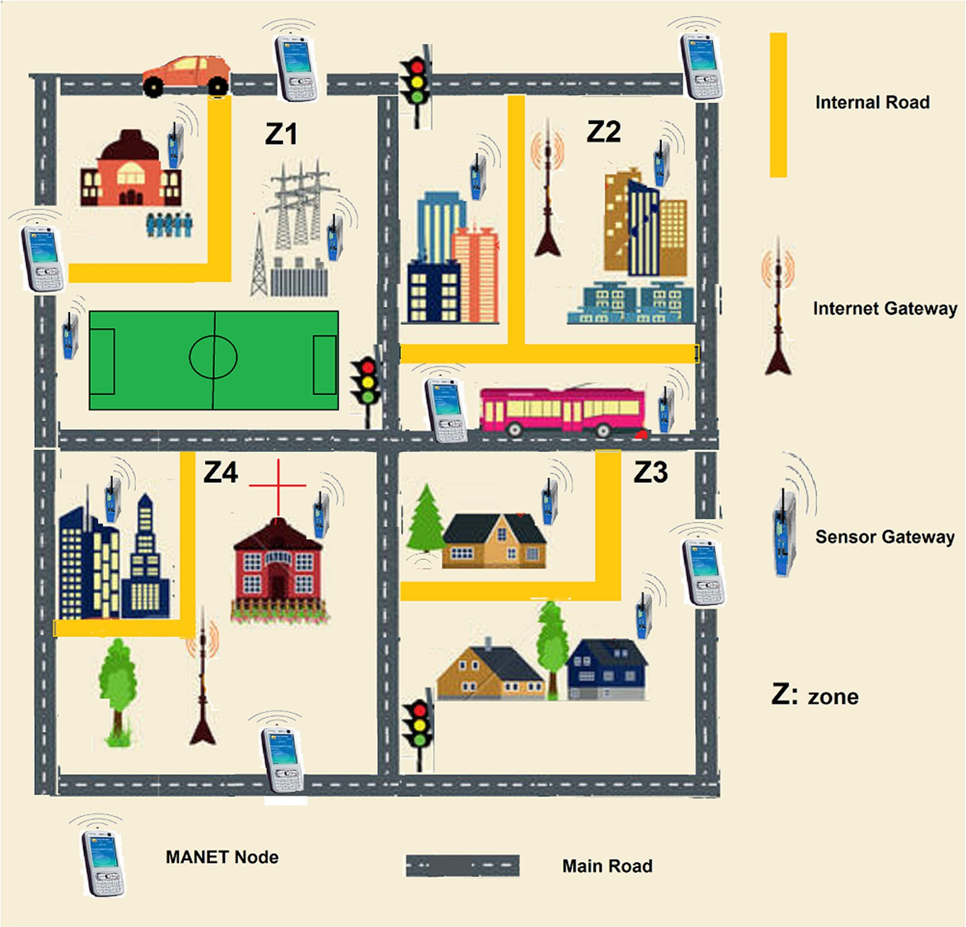

Fig. 1. Proposed IoT enabled Urban area.

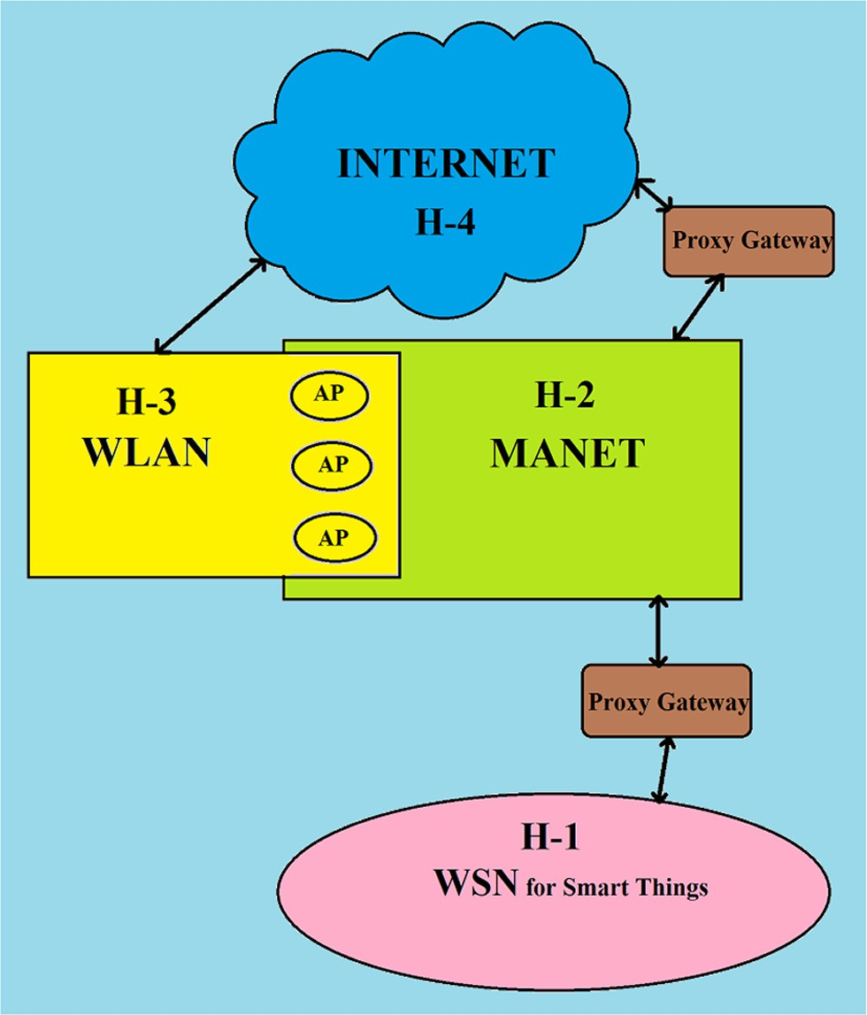

Fig. 2. Hierarchy of wireless networks in Proposed IoT.

data to the Internet, so only three protocols layers are used. Access points at the WLAN at level H-3 also use same set of protocols as the MANET nodes. At the top level H-4, Internet use TCP/IP based protocol stack with IPv6 at the network layer. We have also pro- posed webservers in the IoT architecture, which are used by end user to access the intended device information. Webservers use XML based webpage for different applications and use HTTP appli- cation protocol at the application layer.

Fig. 3 shows the network connectivity of different types of nodes in the IoT network. In our work we have considered the link layer of the sensor nodes either based on Bluetooth technology or based on IEEE802.15.4 technology, which send their sensed data to the MANET node through their gateway nodes. Proposed protocol layers of the sensor nodes with bluetooth technology is also shown in Fig. 4 as well as in Fig. 19.

* 1. *Function of gateway*

All the gateways are basically working between two hierarchies like between H-4 (Internet) and H-2 (MANET) or between H-3 (WLAN) and H-1 (WSN) or between H-2 (MANET) and H-1 (WSN). Different hierarchical levels have their own set of protocols, frequency specifications and energy level. For interoperation between the nodes in two different levels, we have introduced gateways between all the level boundaries. The main function of these devices is protocol conversion and thus need dual protocol stacks for working at two different hierarchy levels. Other than protocol conversion, these nodes also work as sink for the sensor nodes, where data from the sensor nodes are accumulated and for- warded to next higher level nodes.

* 1. *Advantages of multilevel architecture*

Conventional architecture and protocols that has been proposed are based on two level of hierarchy where in one end there are low power sensor networks and on the other end there are high power

Internet gateways. Due to large difference in energy levels, data packet size and transmission power levels, converging these two levels in a seamless manner is very difficult. Incorporating MANET nodes between them reduces the differences and difficulties. We have claimed that our proposed model is more effective and effi- cient than the conventional one. As a proof we have given a qual- itative analysis of both models based on some critical parameters. In the simulation section we have also given some quantitative analysis which consolidate our claim. Following are the parameters used for comparison.

1. Delay of data packet.
2. Design cost and Scalability.
3. Energy.
4. Internet traffic.
   * 1. *Delay of data packet*

Data received by the mobile nodes is reached to one of the Internet gateways through intermediate MANET nodes. It follows the shortest path, which is clear by the proposed MANET routing algorithm (given later in this section). On the other hand in con- ventional model, several sensor gateways are accessing a single Internet gateway from a larger distance either in a time division manner or using CSMA/CA, which actually creates delay as well as loss of energy.

Theorem 1. *Delay of data packets are smaller in our proposed architecture.*

Proof. Let there are *M*1 number of sensor networks in an IoT sys- tem. In conventional model sensor gateways are sending *m* num- ber of data packets to the Internet gateway directly. If transmission speed of each data packet of the sensor gateway is *T* and all the sensor gateways use TDMA based access mechanism

then each sensor gateway sends *m* data packets in s1 amount of

time, where

s1 = *T* × *m* × *M*1 (1)

On the other hand, if same number of packets (*m*) are sent through *l* number of MANET nodes to the Internet gateway, where each MANET node has average *M*2 number of neighbours and also

use TDMA based access mechanism, then for sending all the data packets to Internet gateway, time s2 is calculated as follows.

Required time for sending the first packet is *T*(*l* + 1)*M*2 and for sending rest (*m* — 1) packets, it takes *T*(*m* — 1)*M*2 amount of time

because when one packet reaches the Internet gateway rest of the packets are in pipeline. Thus

s2 = *T*(*l* + 1)*M*2 + *T*(*m* — 1)*M*2 = *T*(*l* + *m*)*M*2 (2)

*l* is number of MANET nodes between source and destination and when load is high, *l* *m*. Thus the above equation is written as

s2 = *T* × *m* × *M*2 (3)

Comparing s1 and s2 it is said that s2 < s1 because in general

*M*2 has lower value than *M*1.

Thus the delay of the data packet is smaller in our proposed model compared to the conventional one. We have also calculated the delay for both the models in the simulation section and shows the same result. h

* + 1. *Design cost and scalability*

Design cost of our proposed model is lower than the conven- tional model. All the nodes which are used, have low power because all the communications are done within a shorter dis- tance. Besides this, generally a MANET node can cover more than

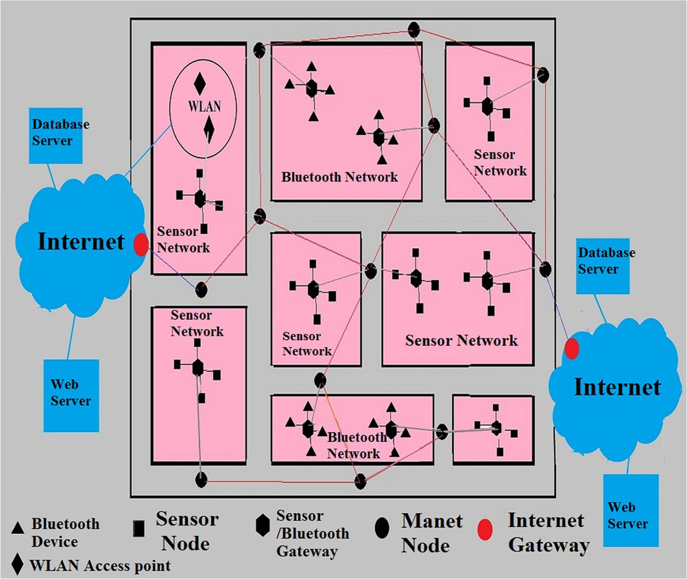

Fig. 3. Proposed IoT network hierarchy comprising Internet, MANET and Sensor networks.

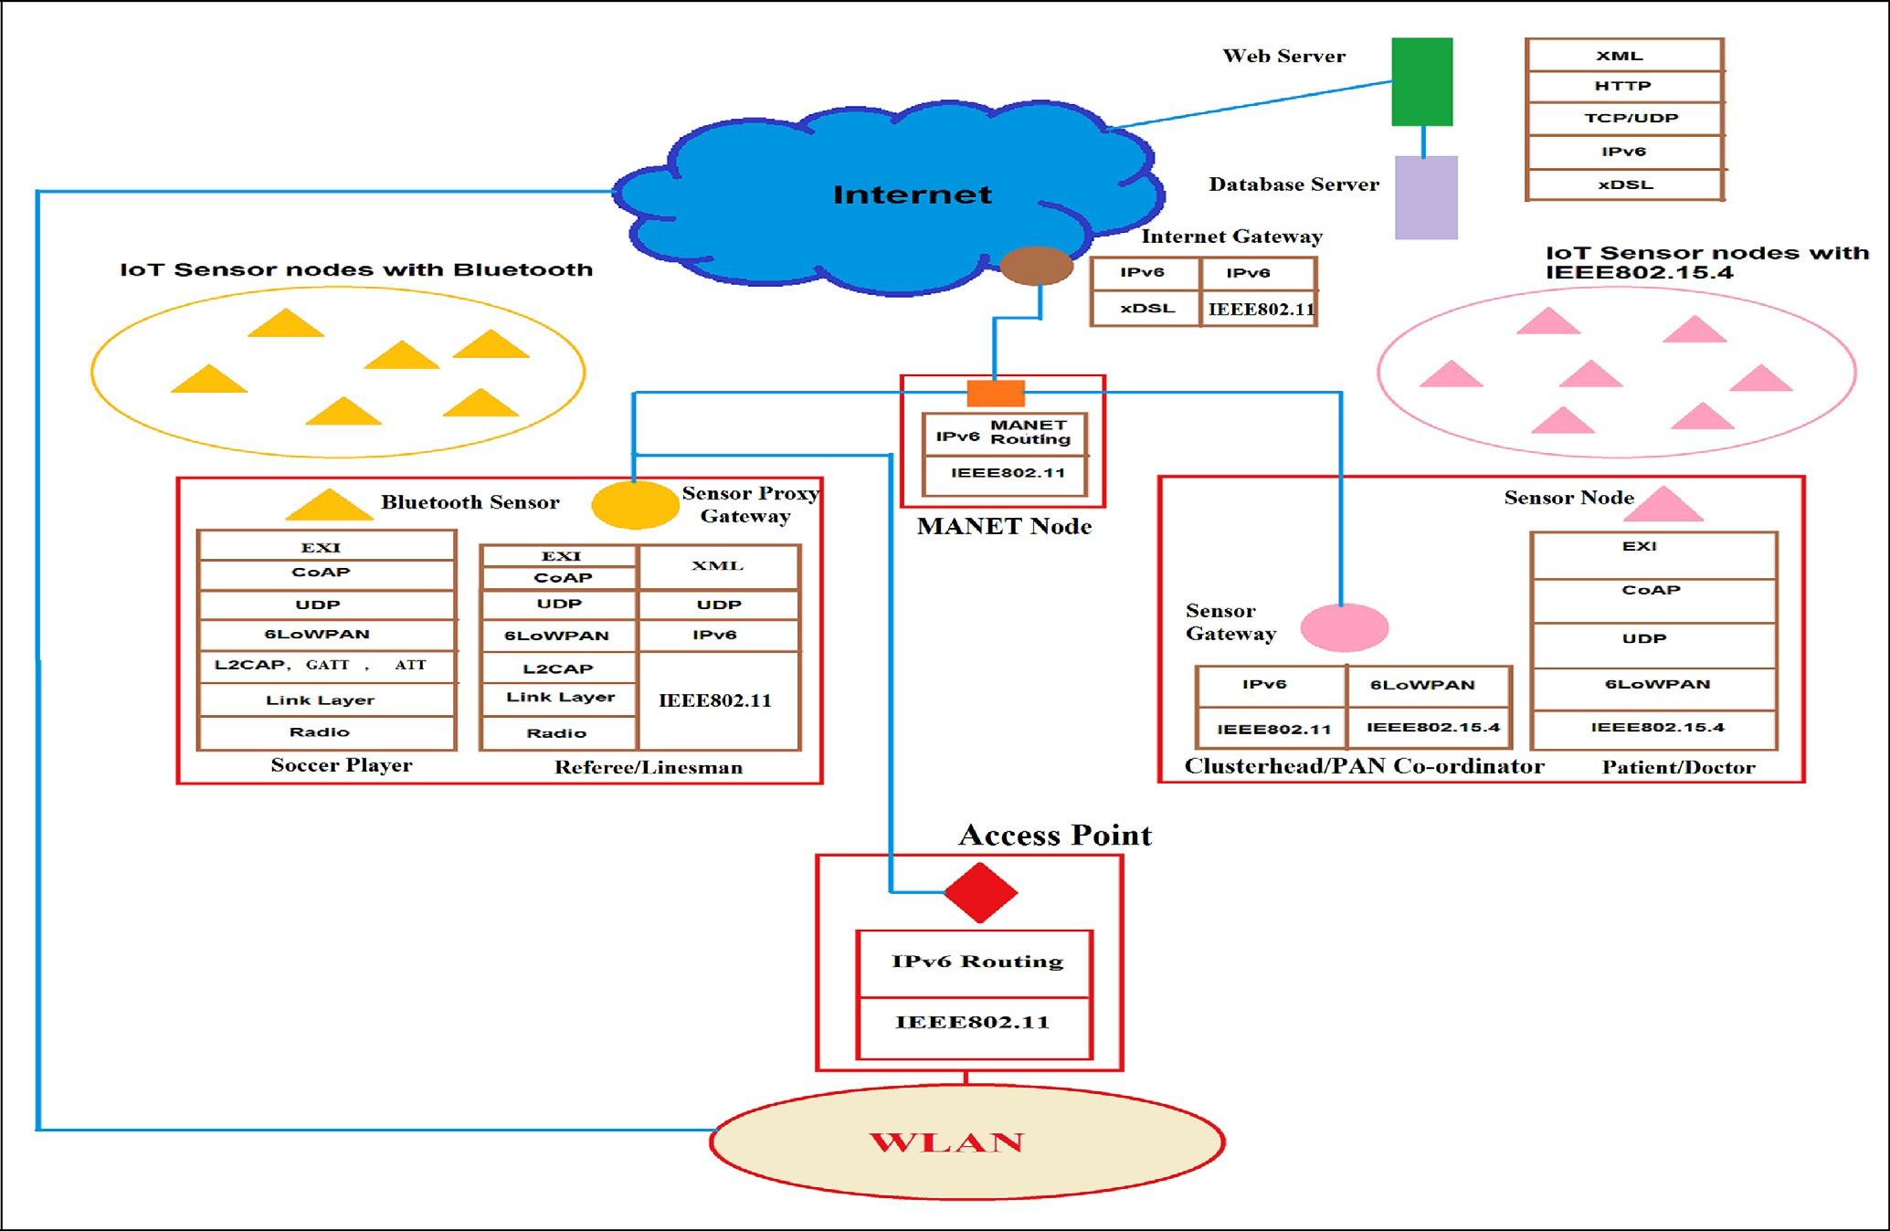

Fig. 4. Proposed protocol architecture of IoT network.

one sensor networks and collects data from them. Deployment of MANET nodes in a city is easy and it does not incur very high cost. Expandability is another big factor in any network system for future growth. The proposed design is highly scalable and thus more and more low power sensor networks with diverse technol- ogy can be included with incorporating small number of MANET nodes into the system which increases a little amount of cost.

* + 1. *Energy use*

In the hierarchical based architecture the energy consumption of the whole system is proportionately distributed over all the nodes in the IoT system. Nodes in each levels are spending some amount of energy to help the data packets reach to the Internet. We have shown that our proposed system is energy efficient.

Theorem 2. *Energy consumption of the proposed system is lower than the conventional one.*

Proof. Let, in conventional model a sensor network sends *N* num- ber of data packets to the Internet gateway which is at *D* distance apart. Thus the energy required by the sensor gateway for trans- mitting the *N* number of data packets to the Internet is *Ec* (Energy conventional) where

*Ec* = *K* × *N* × *D*2 (4)

Where K is the constant of proportionality. If there are *n* number of intermediate mobile MANET nodes in the shortest path between sensor network and the Internet gateway and data packets are reached to the Internet through the shortest path then the energy requirement *Ep* (Energy proposed) is calculated as follows

sensor nodes and above all the protocol stack of the sensor gate- ways, who actually communicate with the nodes beyond the H-1 level.

* 1. *Hospital information System (HIS)*

Hospitals have their own website that is maintained by the sys- tem administrator and the data are uploaded manually. People got all the information like doctors availability, bed charge etc from their site and can also book appointment with doctors. With the advancement of sensor technology and the communication tech- nology a large part of the hospital information system can be auto- mated by the concept of IoT. Every patient is given a wrist-band during admission and remains in the patients wrist until his dis- charge. The band is a sensor device, which records the body param- eters like heart beat, body temperature,etc and sends it to the gateway. More number of sensors can be used for critical patients, which will measure many other body parameters. Before hand over the device to the patient, hospital administrator configure the wrist-band with the patient details like date of admission, Id, name, diseases, doctor Id (under whom patient is treated), bed-id etc. Each patient is identified by the address of the device. Like the patient each doctor and supporting staffs wear a gadget like RFID which can be sensed by sensor. Each medical equipments like MRI, X-ray, CT-Scan, ECG, EEG etc are also attached with a sensor like device which reads the status (operational, number of time used etc.) of the device. Even beds are also attached with sensors to sense the occupancy. Data can also be uploaded to the website by their infrastructure based network like WLAN. Fig. 5 shows the overall view of the hospital and Fig. 6 shows the sensor devices, which are used by the doctors, patients and several examining

*Ep* = *K* × *N*(*d*2 + *d*2 + *d*2 + ··· + *d*2

# ) (5)

devices. So by using the above arrangement the following informa-

1 2 3

*n*+1

tion can be available to the user.

Where in the shortest path, *d*1 is the distance between sensor

gateway to 1st MANET node, *d*2 is distance between 1st MANET node to 2nd MANET node and so on. Finally *dn*+1 is the distance

between *nth* MANET node to Internet gateway. As the MANET nodes are forming the shortest path, thus

1. Numbers of patients are being treated on a day.
2. Patient details along with its sensed body parameters.
3. Available doctors on a day.
4. Equipment availability and usage of it per day.

# *D*2 > (*d*2 + *d*2 + *d*2 + ··· + *d*2

) (6)

1. Bed availability in the hospital.

1 2 3

*n*+1

1. Other non-sensed data like bill amount, bed charge, charge on

Thus from the above three equations, it can be written that *Ec* > *Ep*. It proves that the proposed architecture is more energy efficient than the conventional model. h

* + 1. *Internet traffic*

The proposed model controls the data traffic very efficiently. Beside the architecture, we have also proposed a routing algorithm of the MANET nodes for sending the data to one of the available gateways following the shortest path. We have shown in the sim- ulation section that all the available Internet gateways receive almost equal number of data packets. It also shows that all MANET nodes use equal amount of energy which results little deviation from their mean energy.

4. IoT applications

Here we have considered two IoT applications, where the implementation aspect of the proposed model is discussed. In this section, all discussions are related to the nodes at the H-1 level. Among the two applications, the first one is related to hospital management and the second one is about the very worldwide pop- ular soccer game. Though the study of these two models are not new, but we have proposed different solutions for them, which comprise network architecture, protocols, communication technol- ogy of the wireless sensor devices, mobility models of the mobile

different medical test etc.

Protocol stack and the proposed architecture are shown in the Fig. 7. The wearable bands or gadgets that are used by the patient or the doctors are using the technology IEEE802.15.4 at the link layer and IPv6 in the network layer. IEEE802.15.4 is a suitable technology for wireless personal area network (WPAN) as it consumes very lit- tle battery power. It defines the medium access control and the physical layer [7]. To connect these nodes in the Internet, 6LowPan protocol is used between the routing layer and MAC layer. It seam- lessly combines IPv6 with IEEE802.15.4 by performing header com- pression, fragmentation and reassembly [16,30,17,11,14]. All these nodes send the sensed data to the sensor gateways which are installed throughout the hospital. The gateways use two protocol stacks, one is communicating with the sensor gadgets and another is communicating with the mobile adhoc nodes which are used for data collection. For communication with the sensor gadgets the gateways are using IEEE802.15.4 based link layer protocol and for mobile adhoc nodes, IEEE802.11 based link layer protocol is used.

* + 1. *MAC protocol*

MANET nodes and sensor nodes are using IEEE802.11 and IEEE802.15.4 based link layer respectively. We have considered ISM band as the operating frequency band for both the nodes and the transmission power of the MANET nodes is more than the sensor nodes. Thus some problems of coexistence must arises

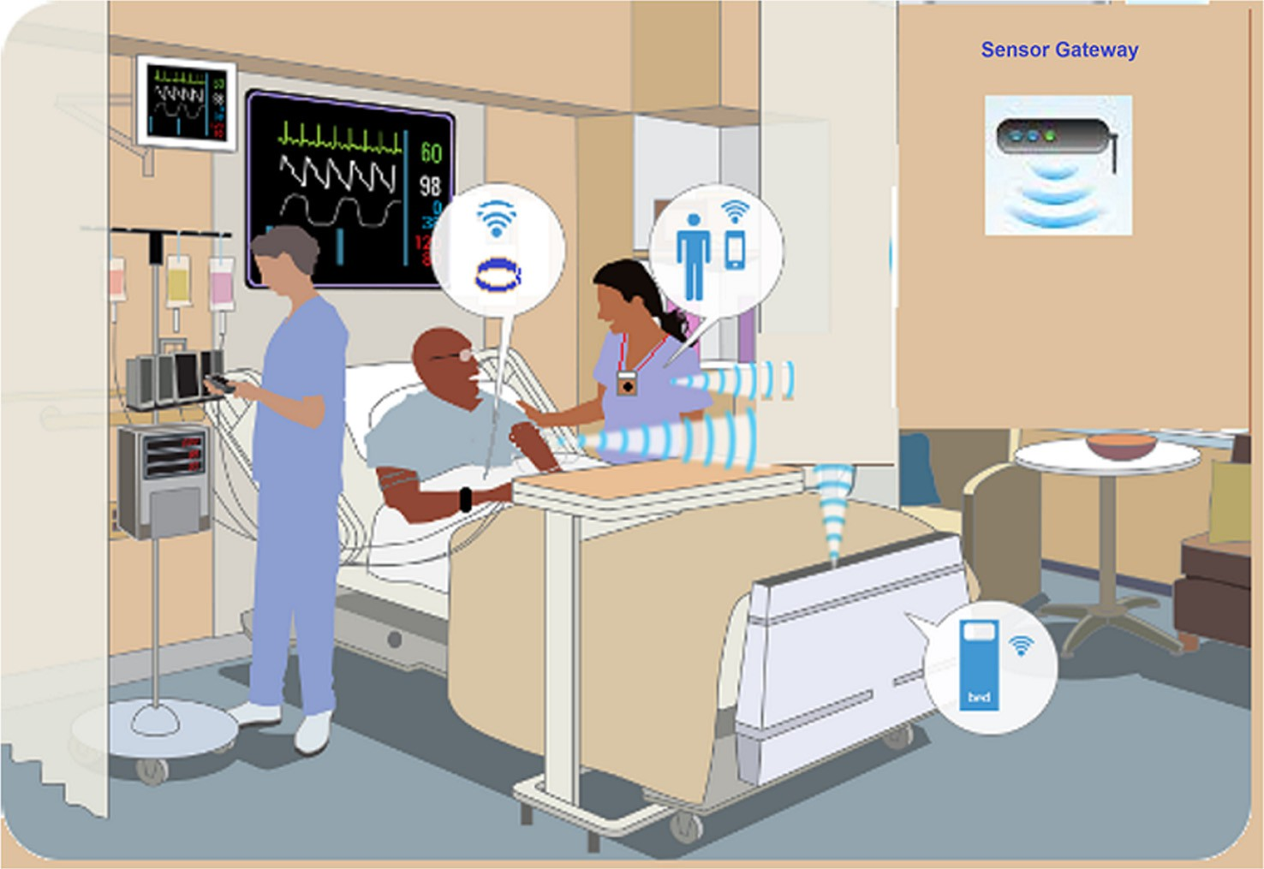

Fig. 5. Hospital management system.

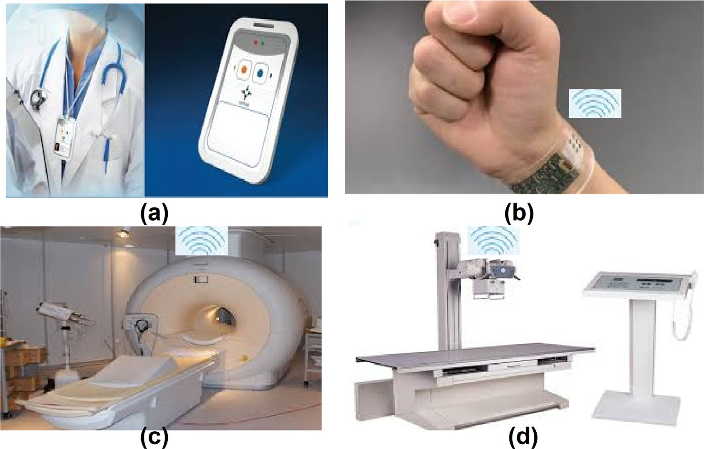

Fig. 6. (a) Doctor with RFID tag (b) Patient with sensor wrist band (c) MRI with sensor node (d) X-ray machine with sensor node.

[36,13]. Due to coexistence interference between these two tech- nologies, nodes should use different frequencies. From Fig. 5, it is clear that each sensor node is directly connected with a gateway sensor node and these nodes form a star network. Gateway nodes send the collected data to the available mobile adhoc node, which thereafter send it to one of the sink (Internet gateway) through some intermediate nodes. As low power sensor nodes and higher power adhoc nodes may communicate simultaneously as well as use the same frequency ISM band, there is a high chance of inter- ference, which ultimately result data and energy loss. So to over- come the difficulty, we have proposed different frequency channels to these two types of nodes to avoid the co-channel inter- ference among each other.

Fig. 8 shows the frequency channels of IEEE 802.11b and IEEE 802.15.4, where in the former, there are 3 non overlapping bands each of 20 MHz. They are ‘1’, ‘6’ and ‘11’ and on the other hand IEEE

802.15.4 uses ‘16’ frequency channels (from ‘11’ to ‘26’) each of 2 MHz. Here we have proposed 2 frequency channels ‘1’ and ‘11’ for adhoc nodes and 8 channels starting from ‘15’ to ‘20’, ‘25’ and ‘26’ for sensor nodes. Sensors, which are under same gateway node use the same frequency channel to communicate with their gate- way, it is any one of the available 8 channels. Each gateway node and its corresponding sensor nodes form a cluster. The available frequency channels are used among the clusters in such a way that no two neighboring clusters have the same frequency channels. Inside the cluster, sensor nodes use guaranteed time slot (GTS) to

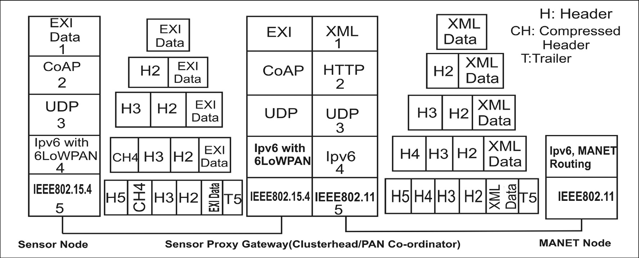

Fig. 7. Protocol stack for hospital management system.

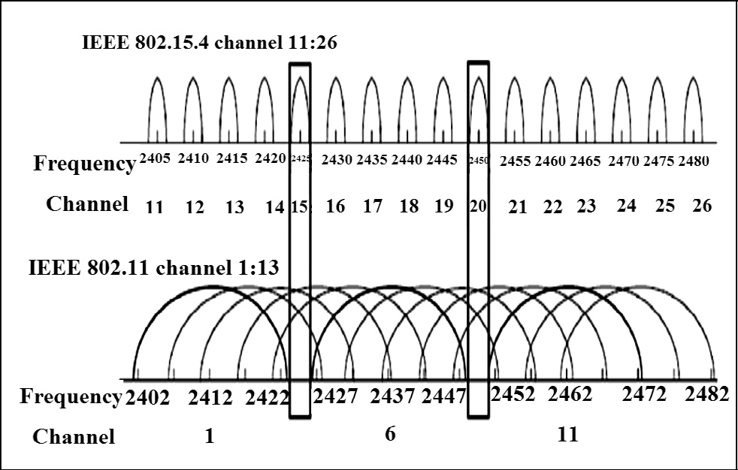

Fig. 8. Frequency channels of IEEE802.11 and IEEE802.15.4.

communicate with their clusterhead after receiving beacon signal from the clusterhead. Gateway nodes use two different MAC proto- cols, one for communicating with the sensor nodes and another for communication with the adhoc mobile nodes. Gateways and MANET nodes use IEE802.11 based MAC protocol, where CSMA/ CA technique is used to access channels. Gateway nodes use the frequency channels ‘1’ to communicate with the adhoc nodes. On the other hand adhoc nodes use the frequency channel ‘11’ to com- municate with another mobile node (Shown in Fig. 9).

Each device attached with the patient, doctors, beds and several other equipments send data to the gateway device which in turn send data to the MANET nodes. Data formats of the data, which are sent by several devices are different. Followings are the for- mats, that we have considered for our simulation.

* + 1. *Application layer protocol and data format*

The IETF has proposed a paradigm known as Representational State Transfer (ReST) which is used for extending the web services over IoT. There is a similarity between conventional web services and IoT services following the ReST paradigm which helps the developers and users to use the traditional web knowledge in IoT web based services. The low complexity counterpart of the tradi- tional web protocol XML and HTTP are the Efficient XML Inter- change (EXI) and the Constrained Application Protocol (CoAP), where application layer protocol CoAP which allows ReST based communication among the energy constrained devices in IoT network.

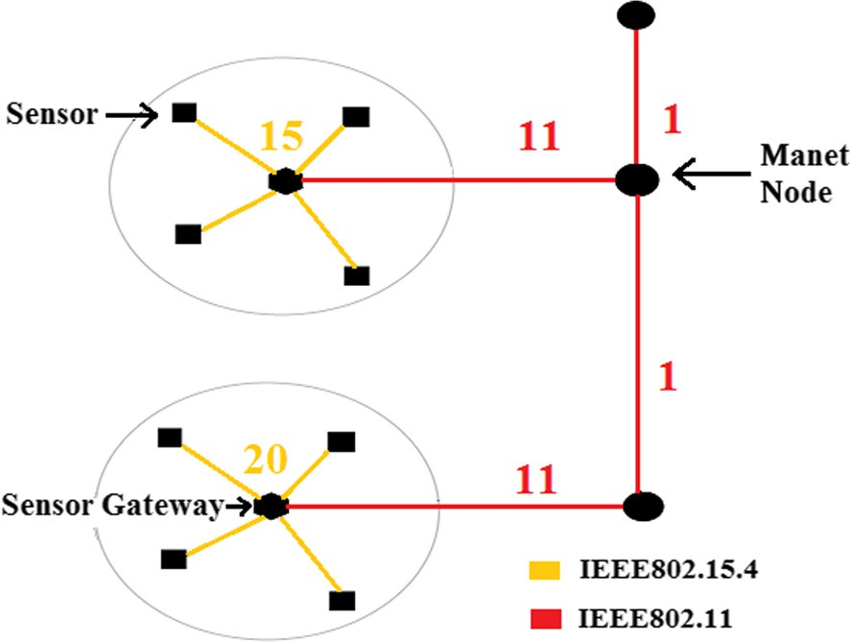Fig. 9. Frequency distribution among nodes.

We have considered the data format of several objects which are connected with the hospital management system. Field length is chosen according to the number of objects, number of possible status of the objects etc. Fig. 10 shows different data format and size for different objects connected to the hospital system. These data is sent as EXI format to the CoAP protocol.

As the nodes used in the HIS are based on IEEE802.15.4 technol- ogy, all the data that are generated are encapsulated in the IEEE802.15.4 frame with a maximum size of 127 Bytes. The size of the protocol headers and data format of the protocols that are used in the protocol stack, are variable. According to the applica- tion and requirement, we have proposed the format and the size of the data that are passing through the protocol layers of the sen- sor nodes (shown in Fig. 11). CoAP protocol adds 4 bytes of header only(without any option field), 6LoWPAN adds 7 bytes of header which includes compressed form of source IPv6 address, com- pressed UDP header, Dispatch header, HC1 and HC2. As the nodes are communicating with the gateway nodes in local loop, com- pressed IPv6 address is taken only 1 byte. Finally IEEE802.15.4 MAC frame adds 9 bytes of header which contains some mandatory headers fields along with source and destination MAC addresses (each of 2 bytes), and a trailer of 2 bytes. Thus the maximum pay- load that can be encapsulated in the frame is 107 (127–27) bytes. But the data (Fig. 10) generated at the application layer is lower than the available payload size. So there is no need of fragmenta- tion and reassembly process at the 6LoWPAN protocol.

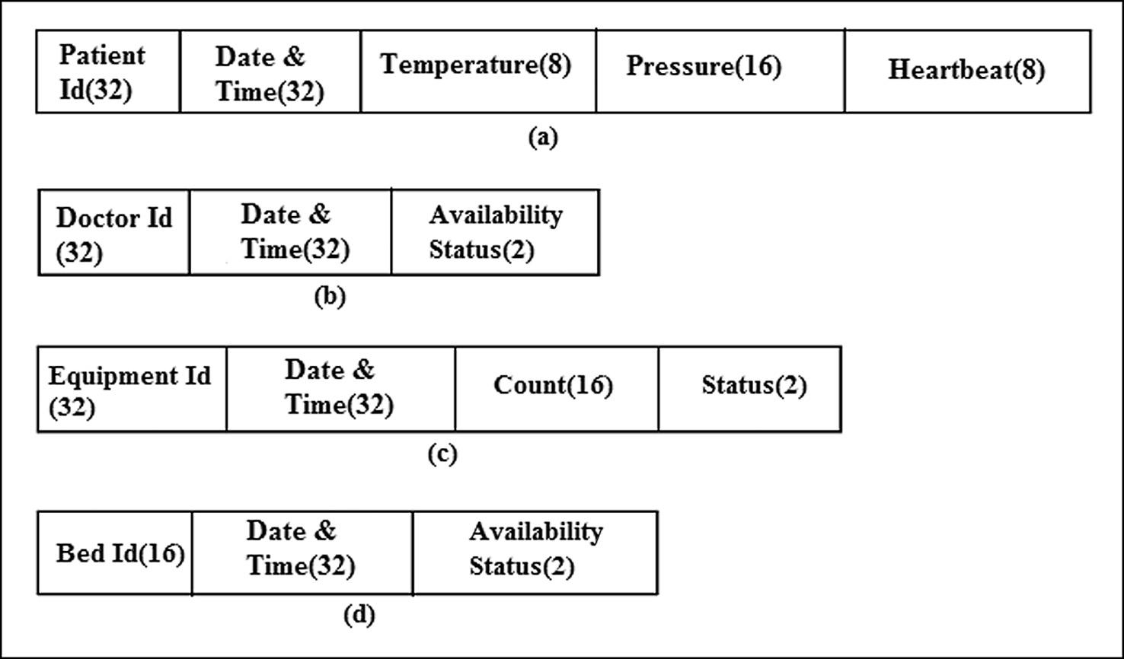

Fig. 10. Data format and size (in bits) for (a) Patient (b) Doctor (c) Equipment (d) Hospital-bed.

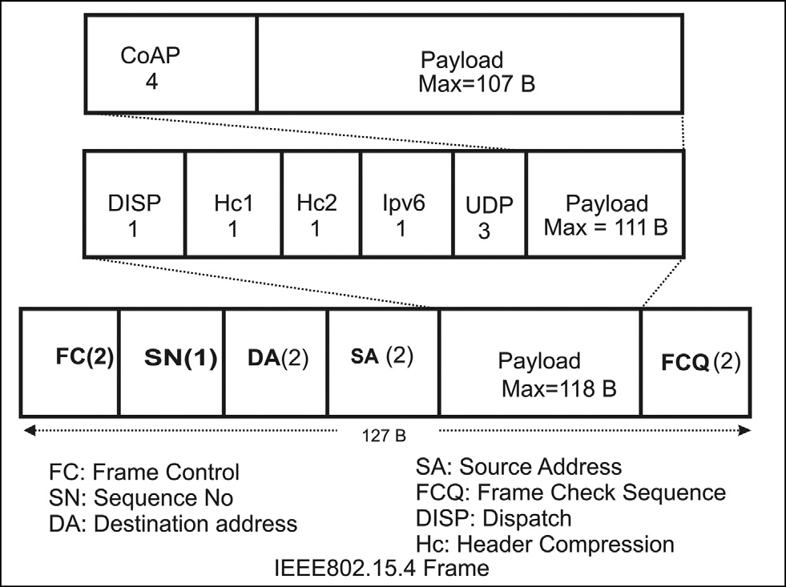

Fig. 11. Frame format of IEEE802.15.4.

* 1. *Monitoring the soccer players through wearable device*

Soccer is very popular throughout the world for several dec- ades. In some country soccer is also named as football. In this paper the term football is actually meant the soccer game. In the world there are several soccer clubs where the club authori- ties are investing huge amount of money for purchasing good footballers for their clubs. The main controlling authority of the soccer is FIFA, which set several standards, rules and regulations for smooth and fair conduct of this popular game. This is a huge entertainment for the football loving fans. Players are improving themselves from their childhood with a dream to play for a reputed club or want to play for their own country. Club author- ities do their best to find good players throughout the world to make a strong team. Throughout the years clubs participate in several championships to win the title. Earning of the clubs mainly come from the sponsors. Football coaches and supporting staffs are also highly paid and they do their best to make a strong team with a good combination and coordination among the play- ers. There is also some bad side of this soccer game. Players are using several performance increasing drugs which are banned

by the FIFA authority. Players sometimes hide their injury and play the game.

We have proposed a model (shown in Fig. 12) consisting of some wearable bio-sensors equipped with GPS and motion sensor, by which several bad practices can be monitored. FIFA authorities, club authorities and coach can take several important decisions based on the sensed data of the wearable bio-sensors. These bio- sensors [24,8] which can test the molecules of drugs which come out with sweat and also check the metabolism rate of the player. These sensors can be used for policing the players while playing and can primarily perform dope test among players. There are lots of available devices like Fit-Bit, which is a wearable wrist band, measures the heartbeat, calories burnt, steps moved, etc and can communicate with the application of the mobile phone using Blue- tooth low energy (BLE) technology. This type of device with addi- tional bio-sensor facility can be used to perform dope test and also coaches and club authorities can take some important deci- sions on the field and off the field. Like other accessories, FIFA should make it compulsory for wearing the device (Fig. 13) in the wrist of the players while playing. Following are the decisions can be taken.

1. Whether players have doped or not.
2. Fitness of the players.
3. Replacement of most tired players on field.
4. Past record can be used to purchase fit players off-field.
5. Position of the players with time.

The overall connectivity of nodes in the network, its architec- ture and protocol stacks of the wireless nodes, which are con- nected to the IoT, is depicted in Figs. 14 and 19 respectively. Each soccer player wears the wristband sensor, which senses sev- eral physical parameters and sweat molecules of the player. These devices use BLE technology for communication with another devices used by the referee and linesmen. The devices at the ref- eree and linesmen act as the gateway, which is operated by BLE and IEEE802.11 both. The referee and linesmen act as masters and players within the range of master are acting as a slaves. Data collected by the referee and linesmen as send to the MANET node which is moving around the ground, by using IEEE802.11 protocol. MANET node thereafter forward data to another mobile MANET node in the road for sending it to the internet gateway.

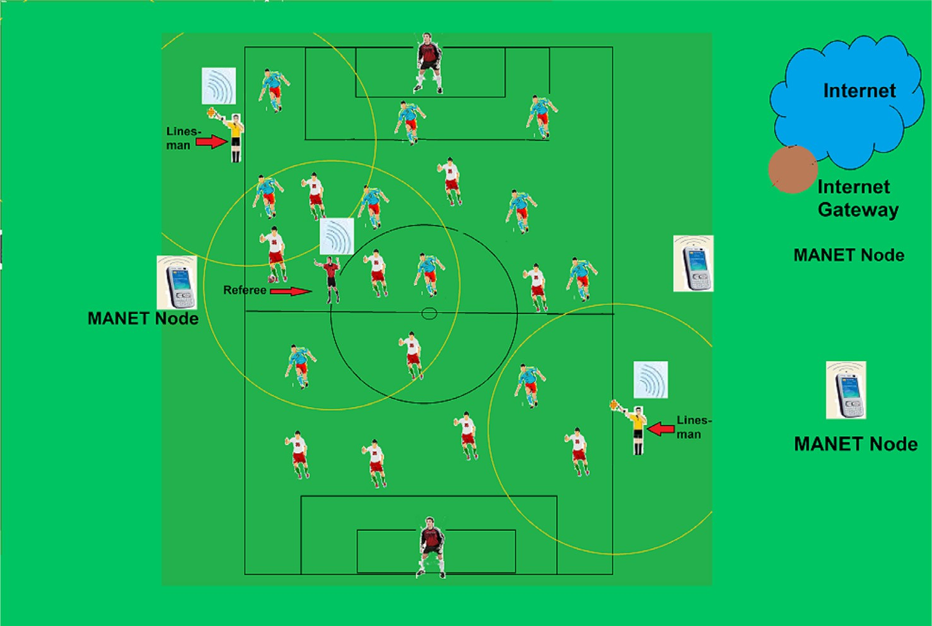

Fig. 12. IoT Soccer model.

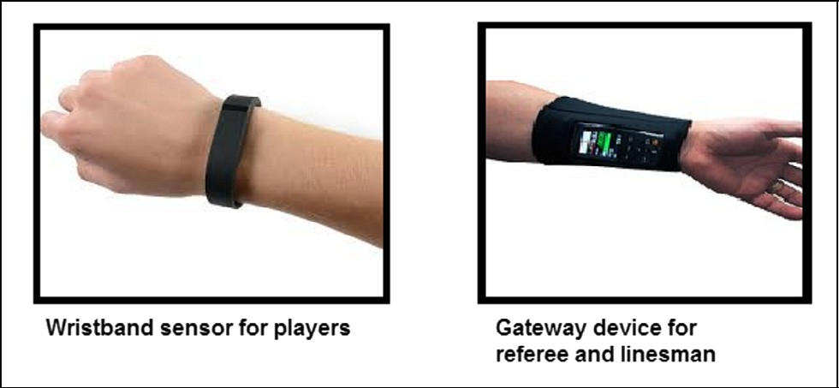

Fig. 13. Wireless device used by the player and Referee/Linesman.

* + 1. *MAC protocol*

Both IEEE802.11 and Bluetooth Low Energy are working in the

2.4 GHz ISM band with a bandwidth of 83.5 MHz, where IEEE802.11 is based on direct sequence spread spectrum (DSSS) and BLE is based on frequency hop spread spectrum (FHSS) tech- nology. BLE uses 40 data channels (channel number 0–39) each of 1 MHz with a spacing of 2 MHz in the 2.4 GHz ISM band and three separate advertisement channels (37,38,39) are spread across the ISM band. Though the advertising channels of BLE are so chosen that it never interferes with IEEE802.11 but the data channels of BLE may interfere. Because both are using the same ISM band [4,20]. Interference between two BLE devices is unlikely because different BLE devices use different frequency hopping sequence. Thus to cope up with the interference, we have proposed a TDMA based mechanism.In Bluetooth technology nodes are act- ing either as a master or a slave.In BLE a master can communicate with large number of slaves simultaneously. Here the player nodes are considered as the slaves and the referee and linesman are act- ing as master. Each player sends maximum three advertisement messages with a time-interval is equal to *AdvInterval* which is sum of fixed interval*Advfixed* and variable interval *Advrandom*. *Advfixed* is the minimum time difference between two advertise- ment messages and *Advrandom* is the random time between 0 to 10 ms, which is used for further wait before sending the next advertisement (Fig. 15). Nodes take *Advdelay* amount of time for

sending the advertisement as well as the request packet and take

*data delay* for sending the data packet.

Advertisement message (Fig. 17(a)) contains some mandatory headers and an optional field UUID, which is a unique 128-bit (16 byte) numbers. Including the UUID in the advertisement packet, masters (Referee/Linesman) can ignore all other sensors in the vicinity except the actual player nodes. The main reason of considering UUID is to prevent communication by any external unauthorized node with the masters. Length of the advertisement message is considered as 34 bytes, which includes 16 bytes mandatory field, 16 bytes UUID and remaining 2 bytes for type and length of UUID optional field. We have considered only one advertisement channel (37 or 38 or 39) which is also used by the master nodes for scanning. Each master scans the slaves with a scan time window s-window and a period of s-interval. As shown in Fig. 16, on receiving the advertisement message, the master node sends a request message to the slave containing the fre- quency information for further communication and number of data (Data-Count) received from different slaves in the present cycle. Request message is considered to be the same size as the advertise- ment message. If a slave receives more than one reply, it chooses one of the masters with lowest Data-Count and send the sensed data to the corresponding master through the data channel which is mentioned in the request message. We have considered 6LoW- PAN over BLE protocol stack and thus the nodes can send IPv6 data through the BLE protocol layers. Though the L2CAP layers has the function of fragmentation and reassembly (FAR), but the size of the data is so chosen that there is no need of FAR and only one data packet is sufficient to send all the necessary information. Consider- ing the compressed header of 6LoWPAN (7 bytes) and CoAP header (4 bytes), maximum amount of sense data that can be sent through the data channel is 11 (22–11) bytes (shown in Fig. 17(b)), which is sufficient to accommodate the proposed data packet(18). We have used four different time slots (shown in the Fig. 15) for collision less communication. In the first slot players are sending their sensed data to either the referee or linesman and the next three slot are used by the referee and two linesman sequentially. These four slots are repeated throughout the game with a period of *T* (shown in Fig. 15).

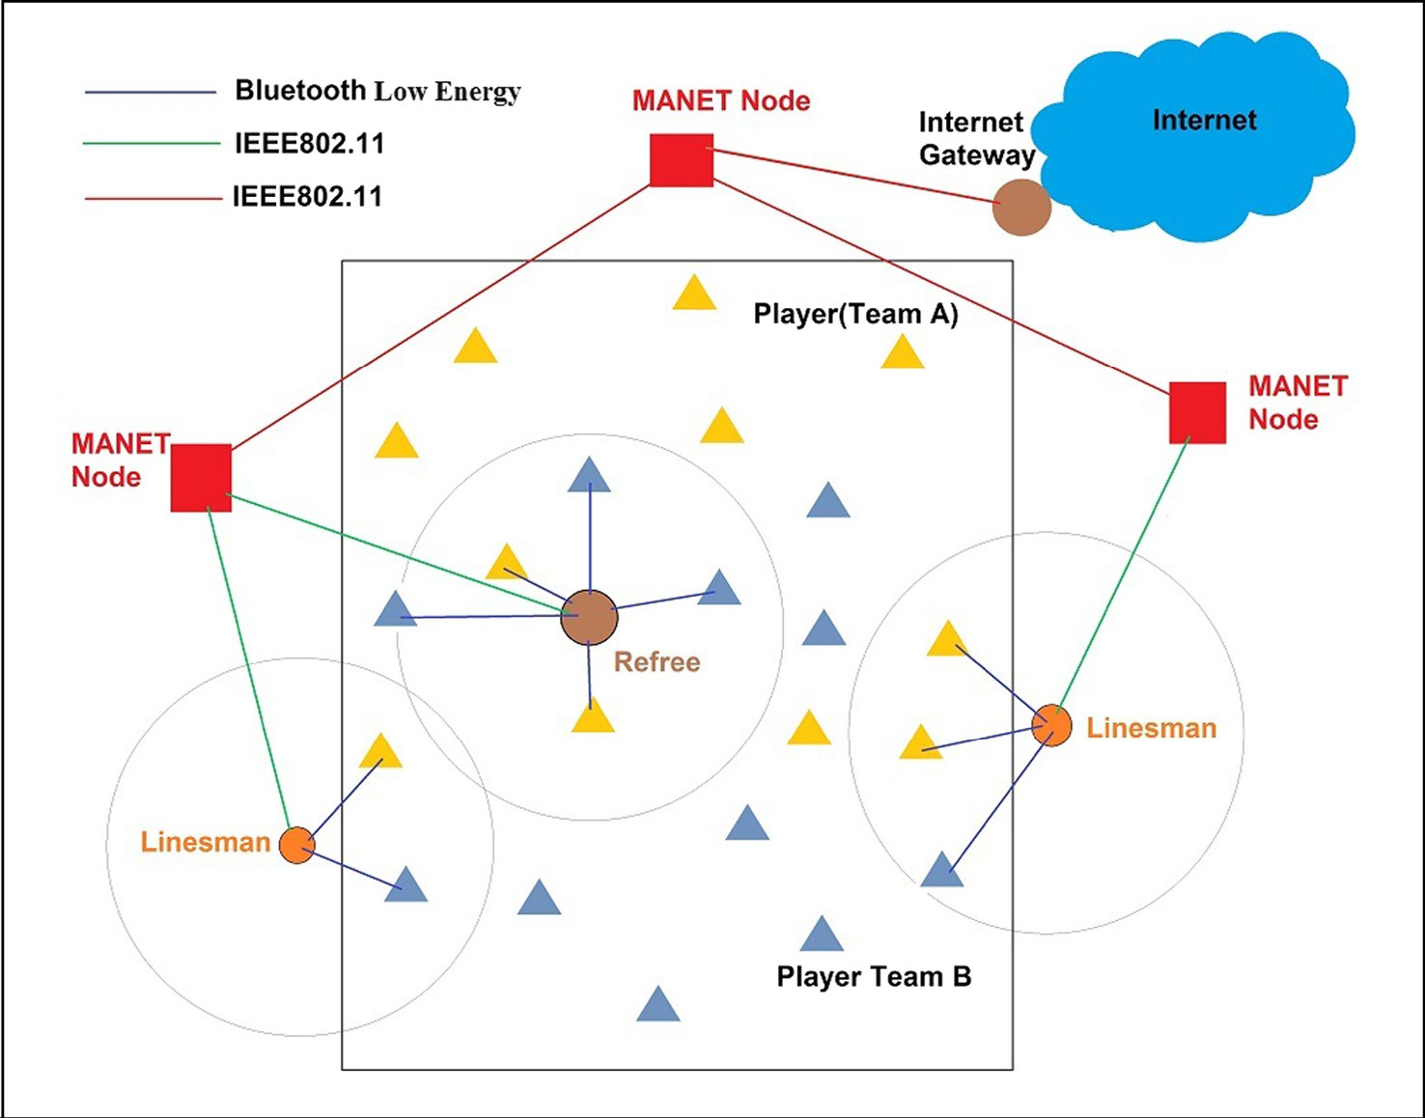

Fig. 14. IoT network connection of the Soccer Game.

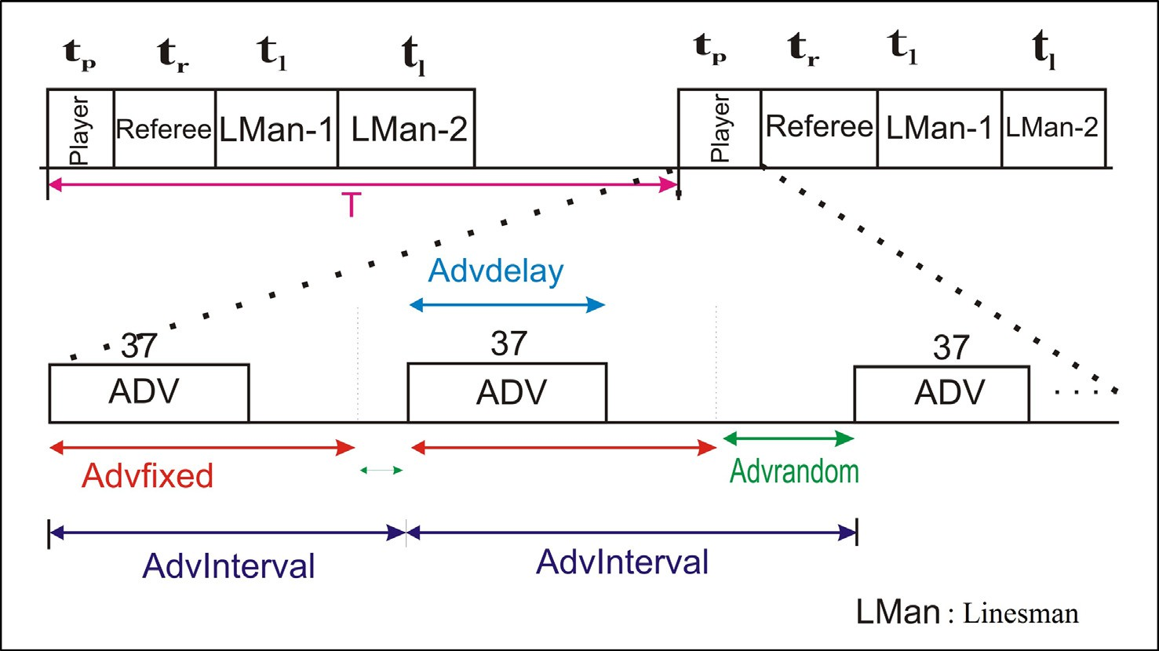

Fig. 15. Advertisement and Time slot used by the devices of soccer game.

Considering the parameters discussed, we have calculated the time period of each portion in the Fig. 15. Let the size of advertise- ment packet, request packet and data packet are *a* byte, *a* bytes and *d* bytes respectively. so the maximum delay for sending a data packet to the master is *tdmax*, where

In the above equation multiplicative factor 8 is number of bits in 1 byte. The value of *tdmax* is set as the *tp*, which is shown in Fig. 15. If we consider the referee and each linesman communicate with max- imum *N* number of players in each cycle, and the data rate is *Rmanet* then the value of *tr* and *tl* are set as

*tdmax* = 3 × [max(*Advrandom*)]2 * *Advfixed* + 2 * *Advdelay*

*d*

*t* = *t* = *N* ×

(9)

*r l*

+ *data delay* (7)

in the above equation last two terms are the delay due to advertise-

*Rmanet*

ment, request and data packets. if the data rate is considered *Rble*, then the above equation can be written as

8(*a* + *d*)

* + 1. *Application layer protocol data format*

Here also the nodes use the same ReST based web paradigm along with the EXI and CoAP protocol in the application layer. we

*tdmax* = 3 × [max(*Advrandom*)] + 2 * *Advfixed* +

*Rble*

(8)

have considered the data format of packet send by the players which is application dependent. Field length is chosen according

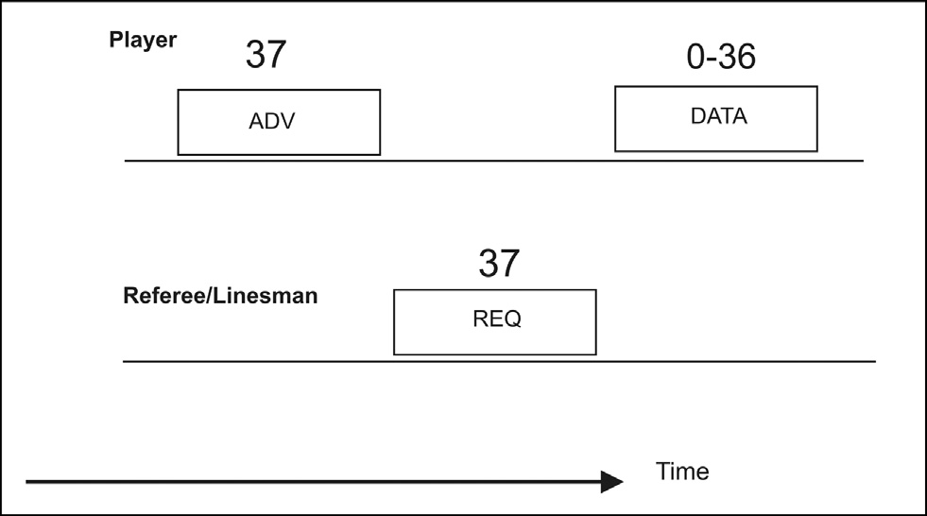

Fig. 16. Advertisement and request response between master and slave in BLE based soccer game.

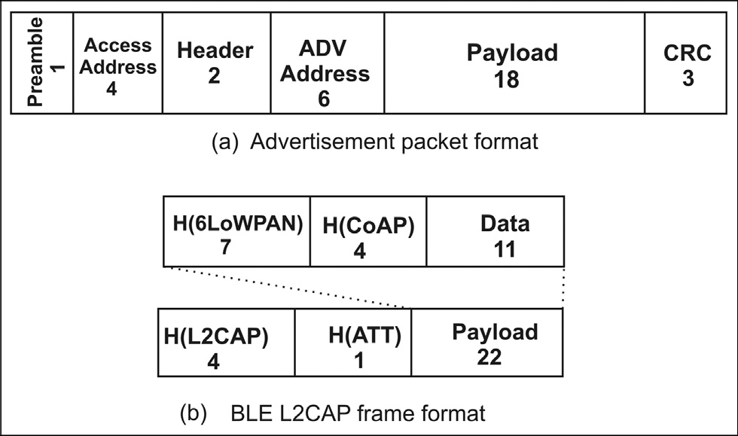

Fig. 17. Advertisement and data packet format of proposed BLE.

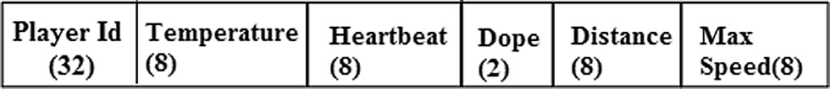

Fig. 18. Data format for the players.

to the number of objects, and the type of data send by the devices. Fig. 18 shows data format for the player object connected to the soccer system.

In both applications gateway nodes collect the data from the sensor devices and send a larger data packet to the MANET node. The data packet generally contains several packets of the sensor nodes. Gateway nodes encapsulate these data packets into one packets and as it reaches to the internet gateway, it is decapsulated and individual packets are being sent to the respective web server. Source IP and Destination IP of individual sensor data packet are mentioned in the data packets. Sensor nodes when send the data to the gateway node, it uses the compressed form of the IP address but it is the responsibility of the gateway nodes to use separate 128 bit IP address of source and destination with each sensor data packet. Gateway nodes also mention its own IP and the IP of next MANET node as destination in its data packet. Fig. 20 shows the data format of the assembled data packet. Sensor nodes may also send some data on emergency situations. Emergency data is trea- ted separately with highest priority. As soon as it comes to gateway node, it is sent separately to the MANET node. We have not men- tioned the data format of the emergency data as it depends upon different application but the data size is taken smaller than the conventional data packet and is given highest priority while for- warding it to the internet gateway.

* 1. *Routing of data and mobility of MANET nodes*

We have assumed that the mobile MANET nodes are GPS enabled and loaded with the map of the urban area. Here we have used proactive routing protocol, to make a route to one of the gate- ways so that it is always ready and available. The routing algorithm used here is finding the routes from each node to the Internet gate- ways only. Though the routing protocol needs little more energy for frequent route set-up but it will reduce network delay. We have used a modified version of distance vector routing protocol where destination is always the Internet gateway. In the case of multiple Internet gateways only information of one is stored in the routing table, which is the shortest one. Every Internet gateway nodes send a ‘‘Hello” message with a TTL value, hopcount and its sequence number. Every time a Internet gateway or MANET node sends or forwards a packet, it will use the new sequence number which is one more than the earlier. MANET nodes which receive the ‘‘Hello” message increment the hopcount by one and modify the routing table if it finds a shorter path compare to the path stored in the table. Table 1 shows the fields of the routing table. If the MANET nodes receive the ‘‘Hello” message from a node which is already selected as the next node to the Internet gateway in the routing

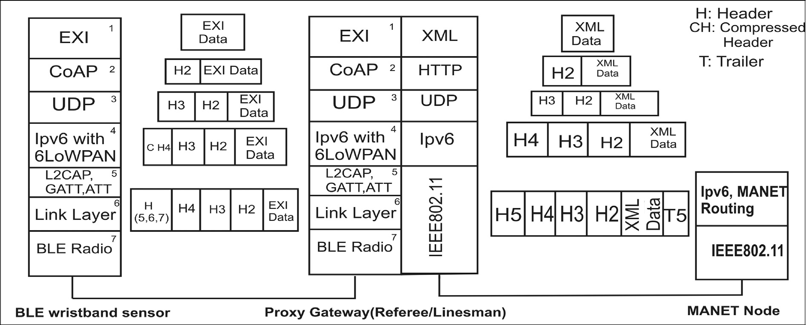

Fig. 19. Proposed Protocol stack used by the devices in IoT model of Soccer.

Table 1

Routing table.

Int_Gateway nxt_hop hop_cnt sq_no

– – – –

– – – –

Table 2

Notation used in algorithm.

Notation Meaning

Locvector Positional coordinates of the manet nodes

*IGi* Internet Gateway ‘i’

*IGorg* Internet Gateway originator

*seqno* Sequence number of the manet nodes attached with each packet

*ni* manet node ‘i’

*hopcount* Number of hops from source to receiver node

*streetnodei* Number of such nodes belong to same street as the node ‘i’

table, modify the table if the sequence number of the sender is greater than the stored one. On receiving the messages, the TTL value will be decremented by one and messages with non-zero TTL will be forwarded. To reduce useless flooding of Hello message from the Internet gateways, appropriate TTL value is chosen that depends on the size of the network and the number of gateway nodes. As the nodes are GPS enabled and loaded with the site map, nodes can locate the position and street location of its own and the neighbors. we have used a concept called ‘‘Street neighbor” which is neighbor of the node as well as belongs to the same street in the map. While receiving the ‘‘Hello” messages, every node finds out the ‘‘Street neighbor” by using the GPS and the street map, then sends this information with the forwarded ‘‘Hello” messages. At a crossing point of the roads, nodes ask the neighbors about their ‘‘Street neighbor” count and decide a road with fewer number of ‘‘Street neighbor” count, must not be the one just visited. The nota- tions, mentioned in Table 2 are being used to represent the Algo- rithm 1.

Algorithm 1. Routing and mobility algorithm

1: \\ GPS location (locvector) of the sender are attached with every packets

2: \\ Internet Gateway broadcast

3: for every *IGi* do

4: broadcast ‘‘Hello” message with ‘id’ *IGi*, fixed TTL, seqno = seqno + 1 and hopcount = 0

5: end for

6: \\ Manet nodes modify routing table

7: for every manet node *ni* do

8: if (received ‘‘Hello” message from *IGk*) then

9: In routing table *Int Gateway* = *IGk*, 10: *nxt hopi* = *IGk*,

11: *sq no* = *seqno*; *hop cnt* = 1

12: end if

13: if (received ‘‘Hello” message from *nk*) then

14: if (*nxt hopi* = *nk*) then

15: Modify *Int Gateway* = *IGorg* ,

16: *hop cnt* = *hopcount* + 1

17: and *sq no* = *seqnok* in routing table

18: else

19: if(*hop cnt* > *hopcount* + 1) then

20: Modify *Int Gateway* = *IGorg* ,

21: *nxt hopi* = *nk*; *hop cnt* = *hopcount* + 1 and

*sq no* = *seqnok* in routing table

22: end if

23: end if

24: if (the *nk* and *ni* belong to same street) then

25: *streetnodei* = *streetnodek* + 1

26: end if

27: if (TTL!=0) then

28: forward the packet to *streetnodei* and 29: one hop neighbors with TTL = TTL-1,

30: hopcount = hopcount + 1, *seqnoi* = *seqnoi* + 1,

31: end if

32: end if

33: \\ Manet nodes mobility

34: if (reached the junction of the streets) then

35: Broadcast a request packet to its one hop neighbors asking for the *streetnodecount*

36: end if

37: if (received *streetnodecount* request message) then

38: broadcast with the reply *streetnodei*

39: end if

40: if (received *streetnodek* reply message from all the neighbors) then

41: Follow the new street ’ST’ which has lowest number of ‘‘Street neighbor”

42: end if

43: end if

1. Simulation and result

We have used Omnet++ 4.3 for simulating our work. In the sim- ulation, we have considered a smart city with 9 zones (as shown in Fig. 21) which contains large office buildings, hospitals, play grounds, electric power stations etc. Wide roads have surrounded all the zones and narrow roads have gone through the zones. In this smart city we have considered an IoT network which contains sev- eral MANET nodes and Sensor nodes, where mobile nodes move in and around the zones of the cities through the wide and narrow roads respectively. Each zone contains several numbers of sensor nodes as well as gateway nodes which are receiving the data from the sensors and forward to some nearby mobile node. In each zone, we have considered two different types sensor networks, which are based on BLE and IEEE802.15.4 respectively. Though these net- works can be used for different applications with different data packet size, but the gateway nodes form larger packets by accumu- lating several sensor node’s data packets and communicate with the MANET nodes. Here we have considered the data size of the gateway nodes are either 1024Bytes or 512Bytes. In each sensor network, gateway nodes collects the data from sensor nodes by using any one the technology (Bluetooth/IEEE802.15.4) and send the processed data to any mobile host by using IEEE802.11b tech- nology. All the Mobile hosts are using IEEE802.11b technology to send their one hop neighbor and finally send it to the Internet Gateway. Several other parameters considered for the simulation are given in the Table 3. We have divided the simulation and results into four parts which are discussed below.

In the first part of the simulation we have varied the number of Internet Gateway nodes as well as the load of the network to observe the performance of the IoT system. These Internet gate- ways are placed in and around the considered smart city. Average delay of two different types of packets is being measured by send- ing a large numbers of data packets in the IoT network. We have also considered short size emergency data, which is given highest priority while forwarding data to next hop node. Fig. 21 shows the snapshot of the simulation environment for the urban area which

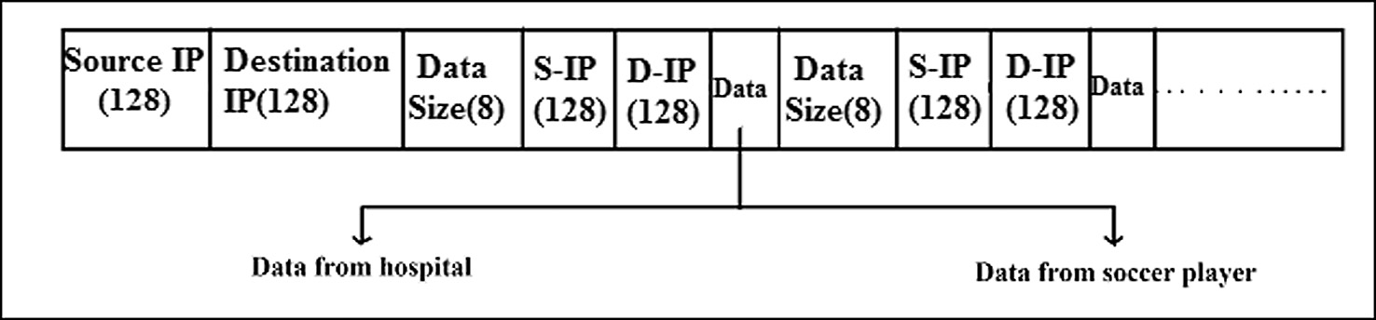

Fig. 20. Data format of assembled data at Gateway node.

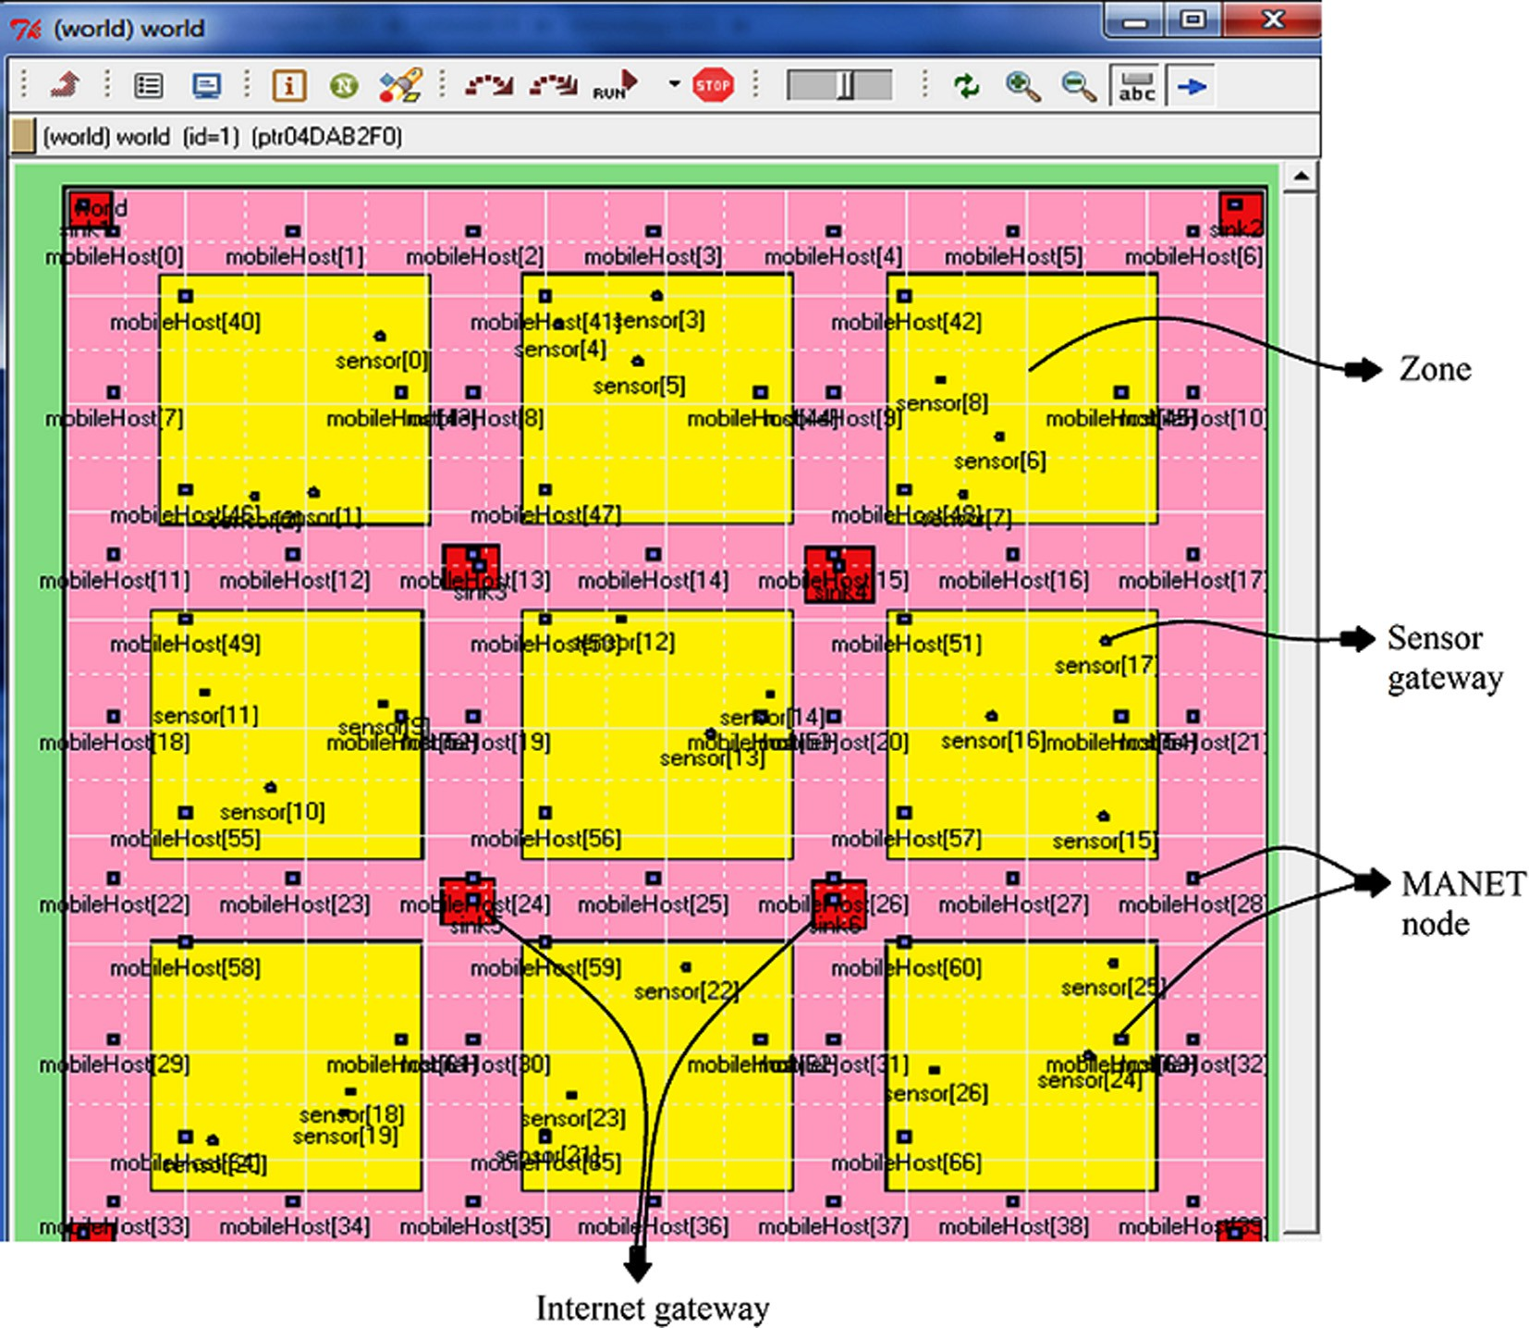

Fig. 21. Simulation environment for urban area.

Table 3

Simulation environment.

Parameter Value

Size of the urban area 1000 × 1000 sq. unit

Number of Zones 9

Number of MANET nodes 50

MANET node transmission

radius(r) 200 unit

MANET node speed [0–15] unit per sec

MANET Data Rate 11 Mbps

Sensor Data Rate 1 Mbps

TTL for MANET Routing 4(# of Gateway = 2) 4(# of Gateway = 4)

3(# of Gateway = 6)

Time interval (T) in soccer game 3 min

is divided into zones and roads. Sensor gateway nodes, MANET nodes and Internet gateways are placed throughout the urban area. Though in the figure sensor nodes have not been shown but in the

simulation, the program codes are developed in such way that in the background the sensor nodes send the generated data to their gateway node.

In Figs. 22 and 23 packet delay is shown with varying load of the network with packet size 512B and 1024B respectively. We have also run the simulations with changing the number of Internet gateways, which are placed in the network in a symmetric manner. From the two figures it is clear that delay of packets decreases with increasing the number of Internet gateways because increasing the number of Internet gateway decreases the average distance from the source zone. On the other way, delay increases as the load of the network increases but slowly and it is obvious, because waiting time at any node may increase on increasing the load in the net- work. Both the graphs (Figs. 22 and 23) behave similarly but delay of packet size 512B is lesser than the 1024 B packet delay. We have also taken care of the emergency data which is smaller in size (100B) and is given highest priority. We have done a simulation by sending 1500 data packets, among which 30 emergency data

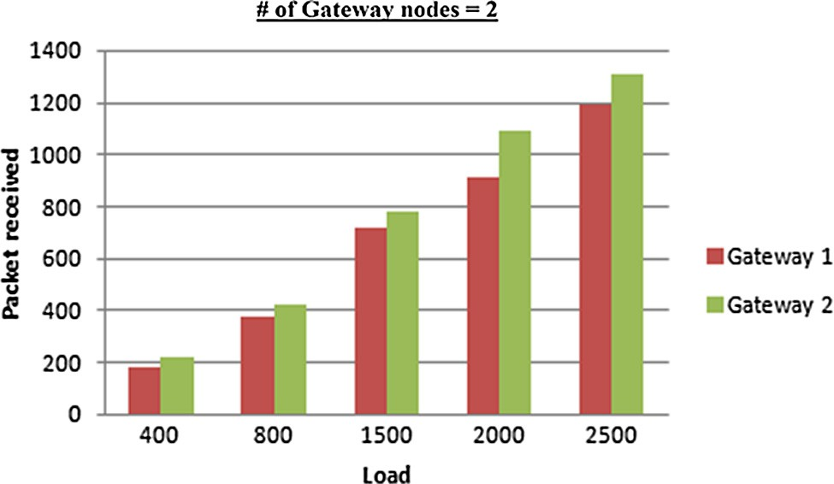

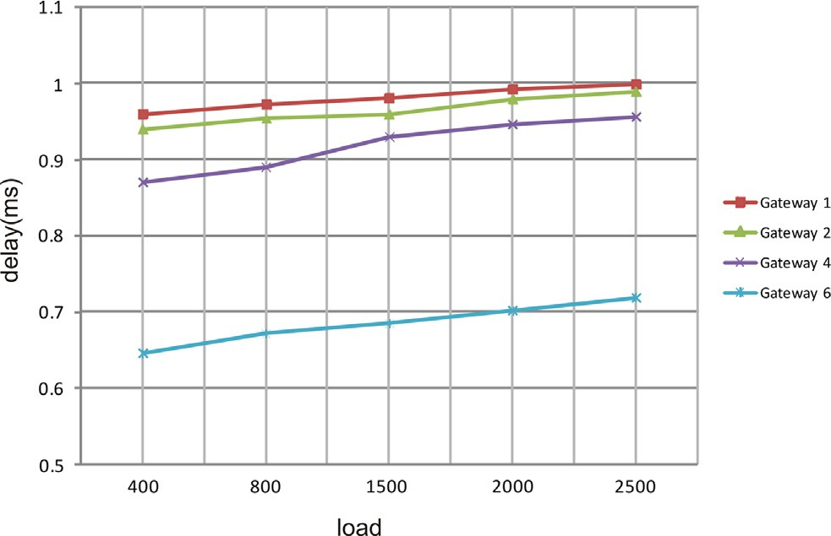Fig. 25. Packets received by the Gateway nodes (# of Gateway = 2).

Fig. 22. Load vs Delay curve for 512B packet.

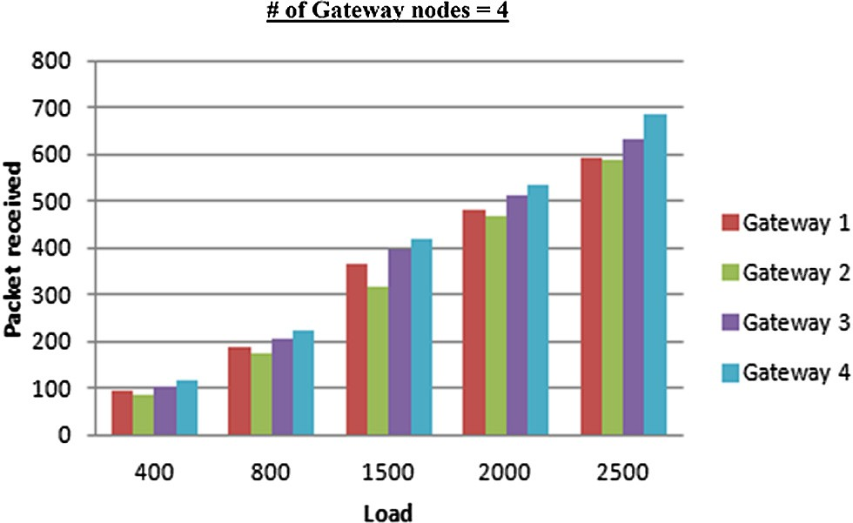

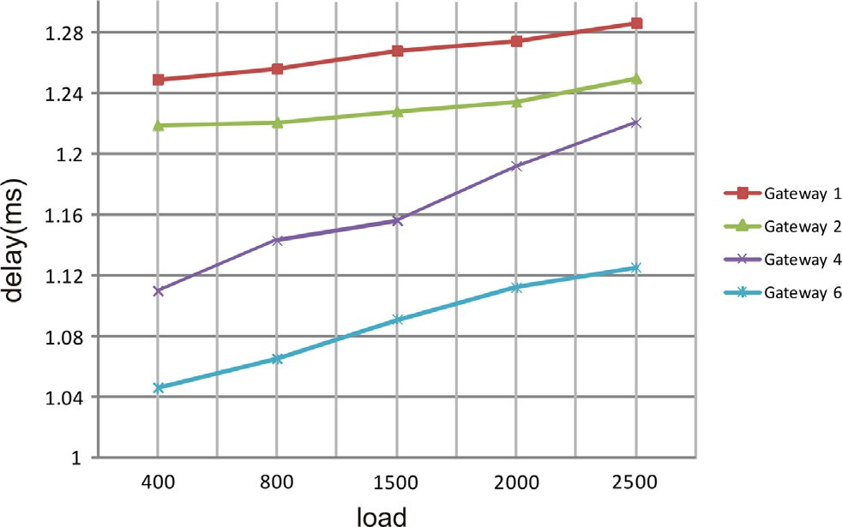Fig. 23. Load vs Delay curve for 1024B packet.

has been transmitted. Fig. 24 shows the delay of emergency data with the variation of the number of gateway. It also behaves in same way, where delay of packet decreases with the increase the number of Internet gateway.

Routing of the MANET nodes are based on the proposed Algo- rithm 1. Here we have used the TTL value of the hello messages as 4 when number of Internet gateway nodes are 2 and 4, and it is set as 3 when number of Internet gateway nodes are 6. In Figs. 25–27, we have shown the load of the gateway nodes with the variation of the load of the network. When number of Internet gateways are 2 or 4 then these nodes are placed at the corner of the field and in both cases all the Internet gateways received almost equal number of data packets(shown in Figs. 25 and 26). But when

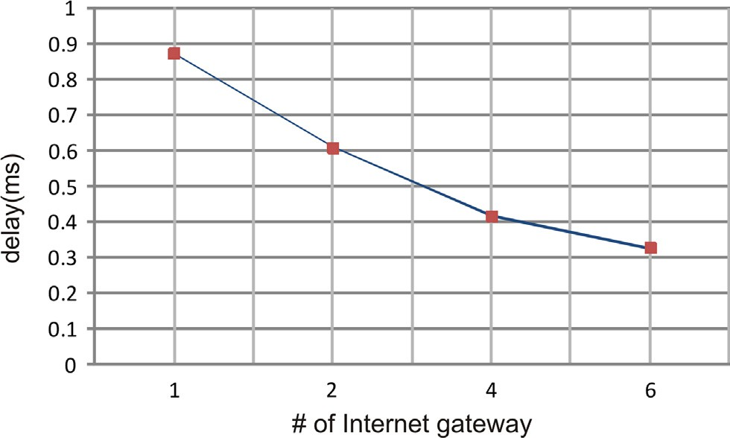

Fig. 24. Delay curve for emergency data packet.

Fig. 26. Packets received by the Gateway nodes (# of Gateway = 4).

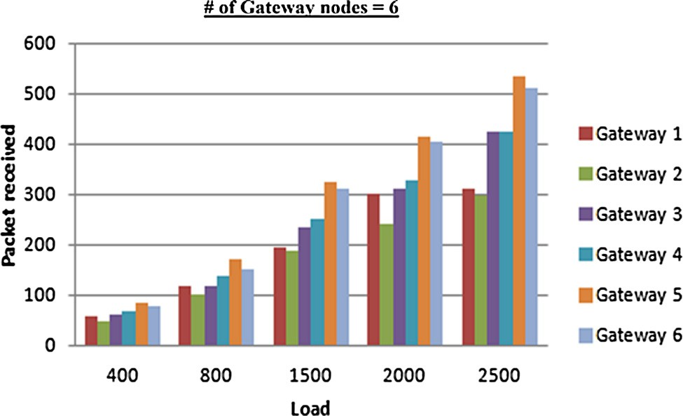

Fig. 27. Packets received by the Gateway nodes (# of Gateway = 6).

number of Internet gateways are 6, there are 2 nodes among these are placed inside the field. So these 2 Internet gateways received more number of packets than other 4 which are placed at the cor- ners. Though according to their position, Internet gateways received almost equal numbers of data packets with similar posi- tion in the field. The results proved the efficiency of our proposed model, which controls the data traffic efficiently.

In the second part of the simulation, we have studied the pro- posed model with different mobility patterns of the MANET nodes. Here we have used two different mobility models, one is own pro- posed mobility model (Algorithm 1) and another is Random Way- point model. In the Random Waypoint model, nodes stop for some time interval between two successive moves and then move with a velocity for some fixed time interval towards a particular direction

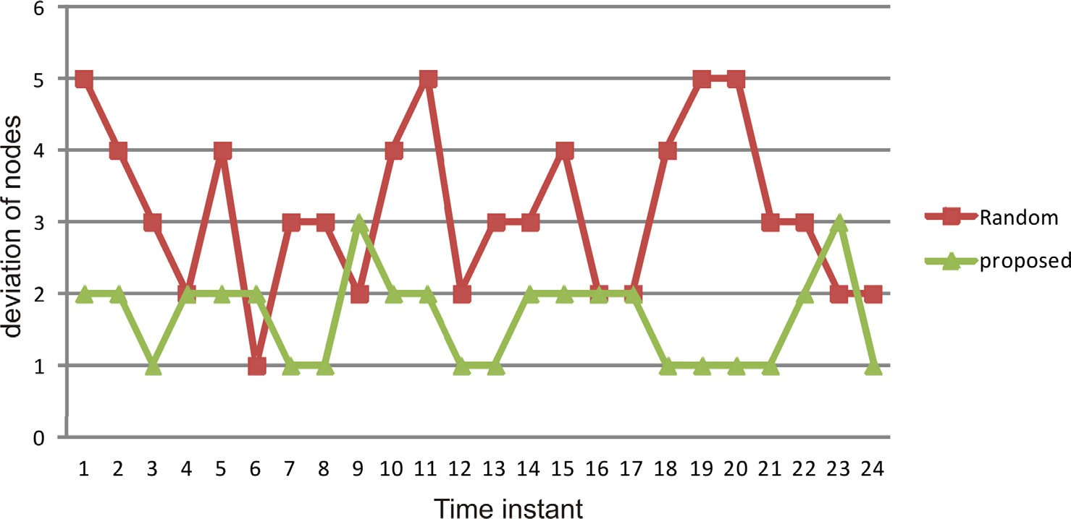

Fig. 28. Deviation of number of nodes in each zone with time.

which is chosen randomly. In this part of simulation we have con- sidered 4 Internet gateways that are placed at the 4 corners of the deployment field. Fig. 28 shows the deviation of number of nodes from the mean around the network zones at different time instant of the simulation, where the velocity of the nodes is considered 15 units/s. It is clear that in our proposed model number of nodes are fairly distributed around the sensor zones, where the change is minimal from the mean. we have also calculated the average packet delay (average time required to reach Internet gateway from the sensor gateway) for both types of mobility models with the change of velocity of the mobile nodes. Figs. 29–31, show the change of average packet delay with increasing the load of the net- work for the node velocity 15 units/sce, 10 units/s and 5 units/s respectively. Though the delay doesn’t change too much with the velocity, but in the Random Waypoint mobility model, delay is

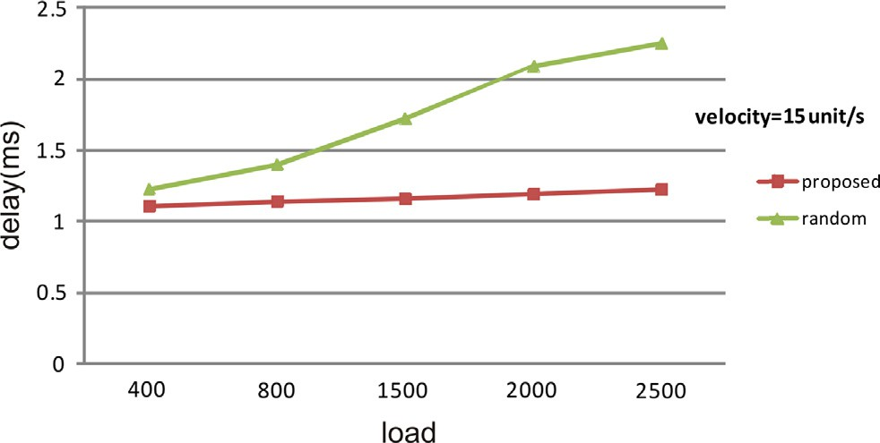

Fig. 29. Load verses delay curve (velocity = 15 unit/s).

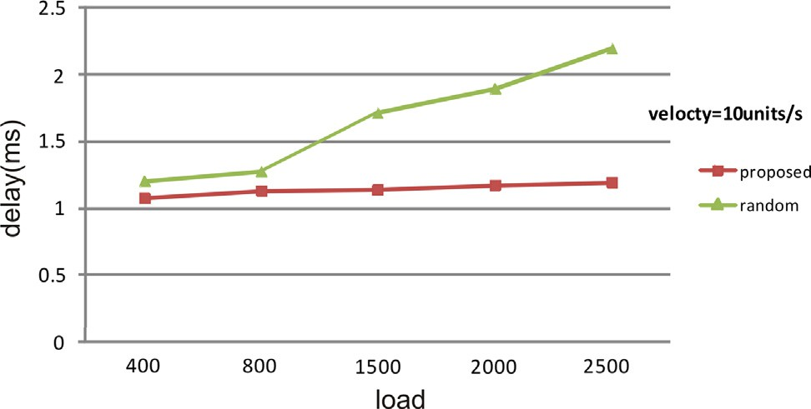

Fig. 30. Load verses delay curve (velocity = 10 unit/s).

increased more sharply with increasing load, than the proposed mobility model. In Fig. 32, it is seen that energy variance of MANET nodes is lower for our proposed mobility model, because all the MANET nodes are used uniformly whereas in the case of Random Waypoint model, there are some nodes that are used heavily com- pare to others and as the load increases energy variance gap between these two models increases more.

In the third part of the simulation, conventional IoT model is considered for comparing with our proposed model, where two important network parameters, average packet delay and energy are compared. The simulation environment consists 27 number of sensor gateways for both the models and there are 50 MANET

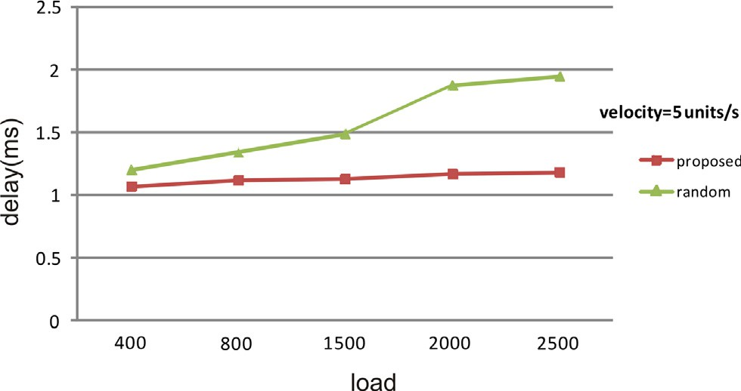

Fig. 31. Load verses delay curve (velocity = 5 unit/s).

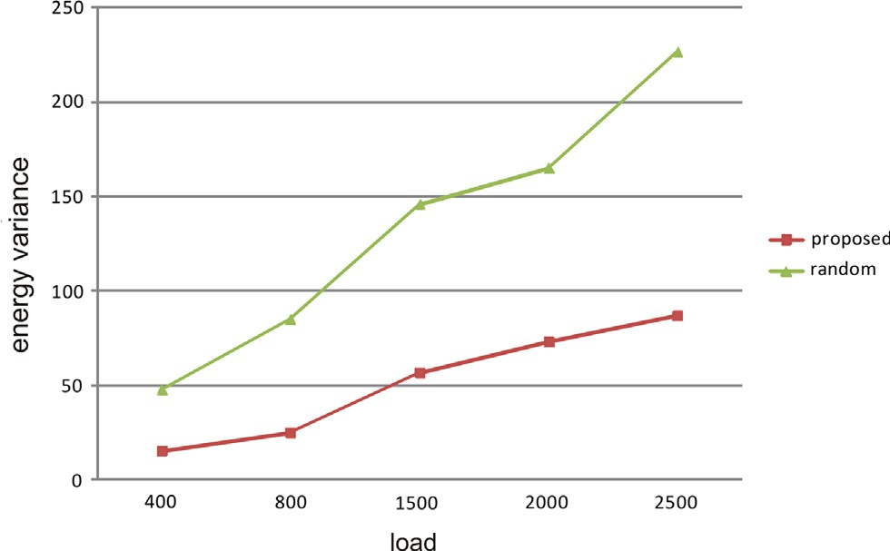

Fig. 32. Load verses energy variance (velocity = 15 unit/s).

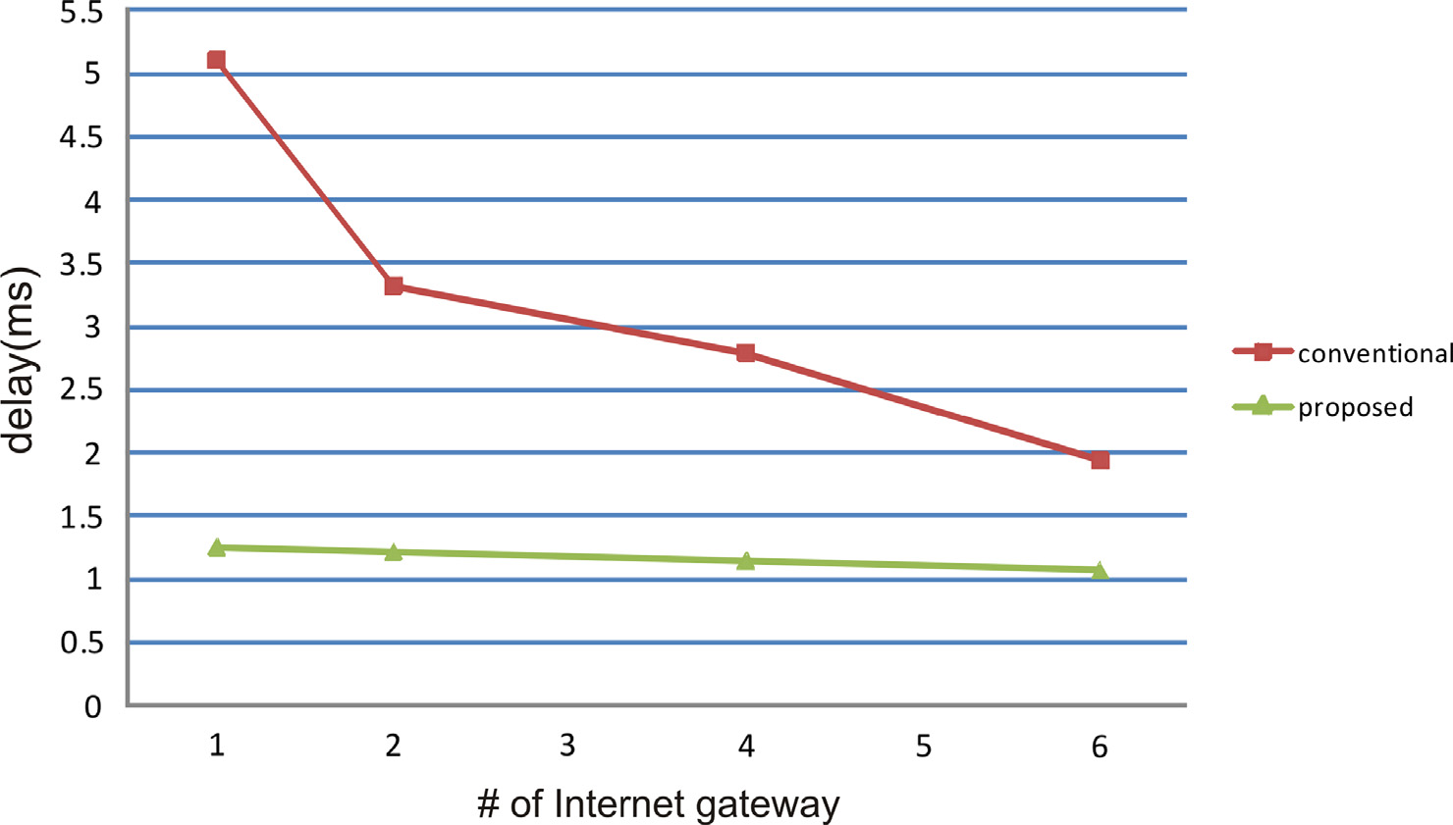

Fig. 33. Delay of data packet comparison between proposed and conventional model.

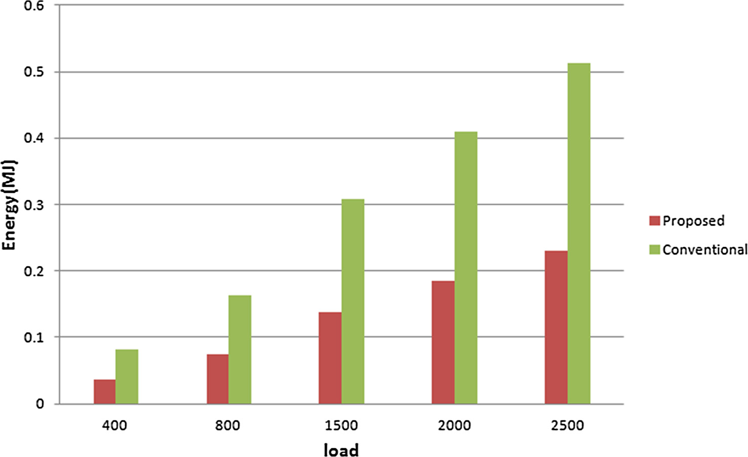

Fig. 34. Energy comparison between proposed and conventional model.

nodes for our proposed architecture. Node velocity is considered as 15 units/s and all MANET nodes and the sensor gateways are using CSMA/CA based access mechanism. In this simulation, load is con- sidered as 800, where packet delay is observed with changing the Internet gateway number. As we use more number of Internet gateway nodes, packet delay decreases in both cases but it has always lower value in our proposed model (Fig. 33). We have also observed the energy consumption of the whole system in both models with the variation of load of the network.

We have considered a first order radio model, where energy consumes by the radio is *ETx* to transmit a k bits message over a dis- tance of d.

*ETx*(*k*, *d*)= *Eelec* × *k* + s*amp* × *k* × *d*2, *d* > 1 (10)

Therefore, the power consumption of data transmission between two nodes is proportional to the square of their distance. Similarly energy consumption while receiving of data:

*ERx*(*k*)= *Eelec* × *k* (11)

while k is the data volume to be transmitted (bit), d is the distance

between two nodes, *Eelec* is the energy consumption to carry out data transmission in terms of nJ/bit, s*amp* is the energy consumption

constant used to expand radio coverage in terms of nJ/(*bit* × *m*2). Total consumed energy of each node = P *ERx* + P *ETx* = total con-

sumed energy of data receiving + total consumed energy of data transmitting. *Eelec* is considered as 50 nJ/bit and s*amp* is consider

100 nJ/(bit m2). Fig. 34 shows the result, where total energy con- sumption in conventional model is much higher for all the loads. The above results proved that the proposed model is energy effi- cient and has smaller delay that proved our previous claims.

In the fourth and final part, we have done a simulation for the soccer game shown in Fig. 35, where the size of the ground is cho- sen as 100x80 square unit. There are altogether 22 footballers for Team A and Team B, they are deployed in the ground by consider-

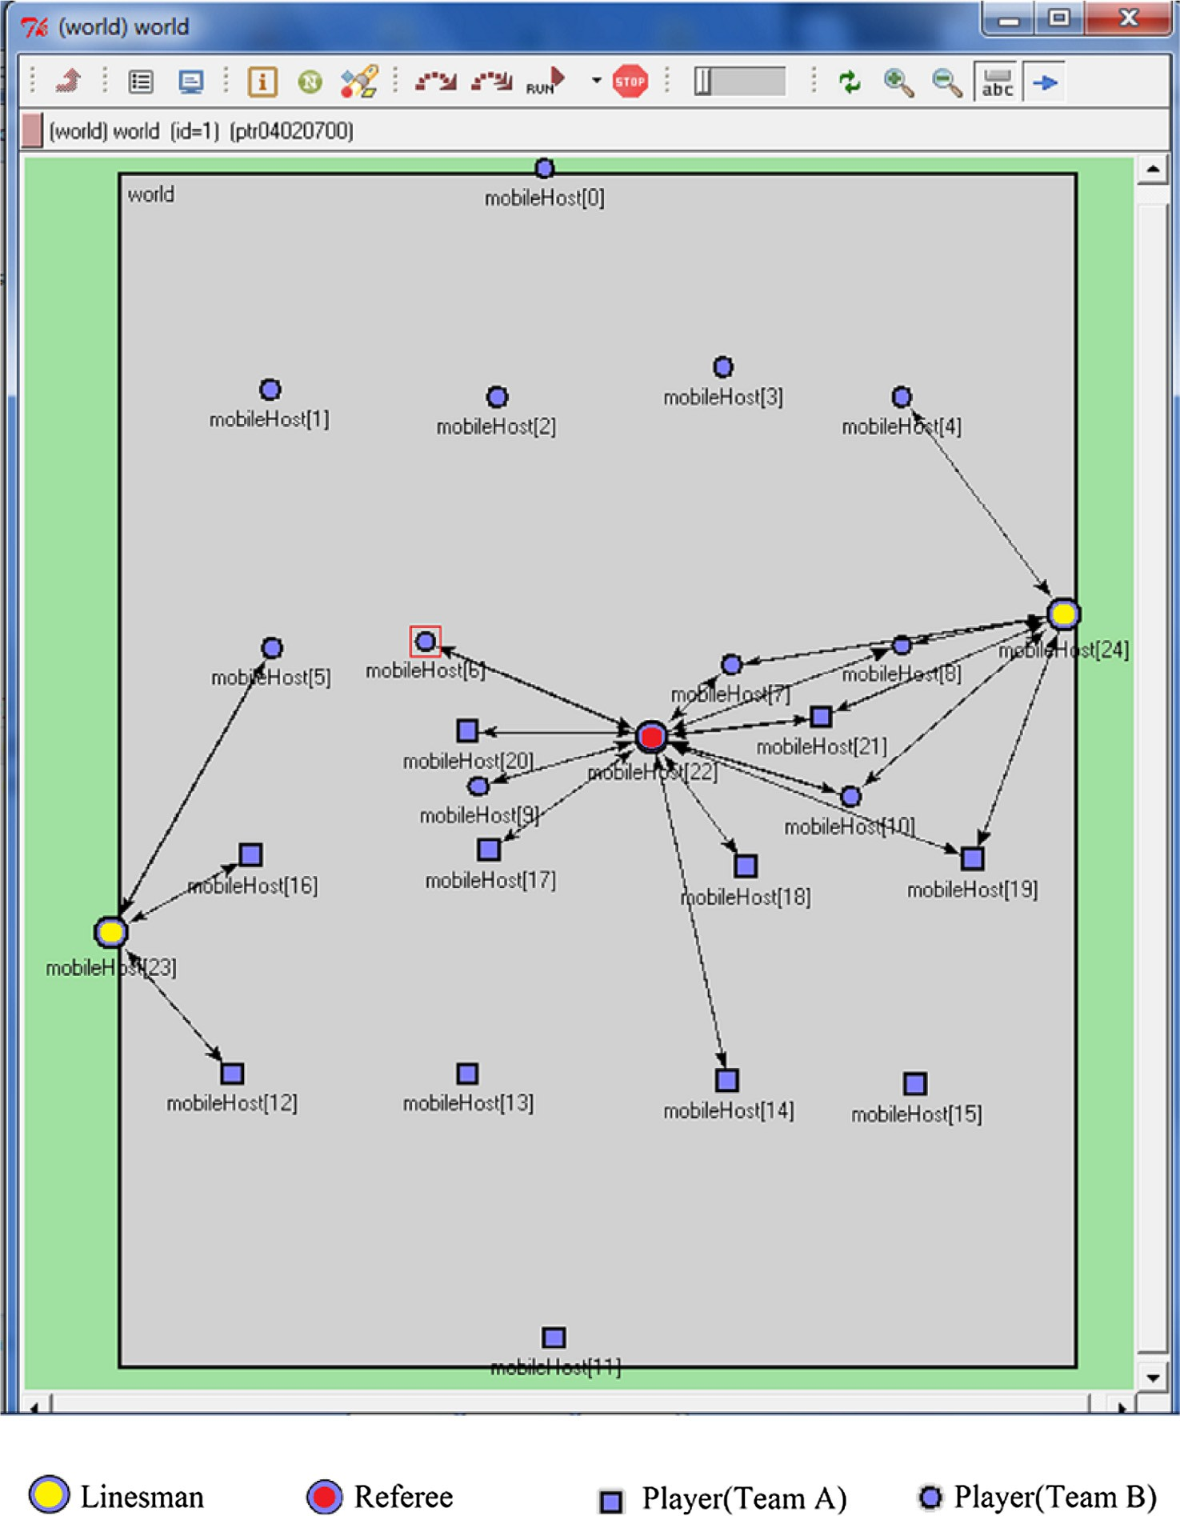

Fig. 35. Simulation environment for soccer game.

ing the playing style 4–4–2. We have imposed some restriction on each players movement, where normally he or she can only move to his or her zone but occasionally the player can move out of his or her zone. Minimum and maximum speed of the players except the goalkeepers are chosen as 0 and 5 unit/s and for goalkeeper, very little movement around his or her initial position is considered. We have considered one referee and two linesmen, where move- ment of the linesmen are considered through the border line of the longer side of the ground and the referee move inside the field. In real game, the referee always try to be close to the ball, his movement is partially random. The speed of the referee and the linesman is also chosen between 0 to 5 unit/s.

We have run the simulation for 90 min simulation time and found the Average Time Difference (ATV) between two successive data transmission of each player and also Data Transmission Count (DTC), the number of times each node is able to send the data through the referee or lineman. Main reason of the finding the

two parameters is to prove the feasibility of implementing the soc- cer model. Players should be able to send their parameters to the internet several times and time gap between two successive trans- missions should not be very high. As the sensors are using Blue- tooth Low Energy (BLE) technology so at any instant any number of sensors able to transmit the data to the master (Referee or Lines- man). For simulating the soccer model, players(slave) use the advertisement interval(Advfixed in Fig. 15), which is 20 ms and the referee or linesman, who are acting as master, scan the adver- tisement messages with time interval 20 ms (‘‘Scan-interval”). In Figs. 36 and 37, DTC and ATV are being shown for Team A with the variation of ‘‘Scan-window” between 15 ms to 5 ms and Figs. 38 and 39 show the DTC and ATV of Team B for same ‘‘Scan-window”. Every 3 min(T in Fig. 15), players try to send their sensed data. From the graphs it is clear that each player’s information is avail- able several times throughout the whole play time with reasonable time interval in between. So the results show the feasibility of our

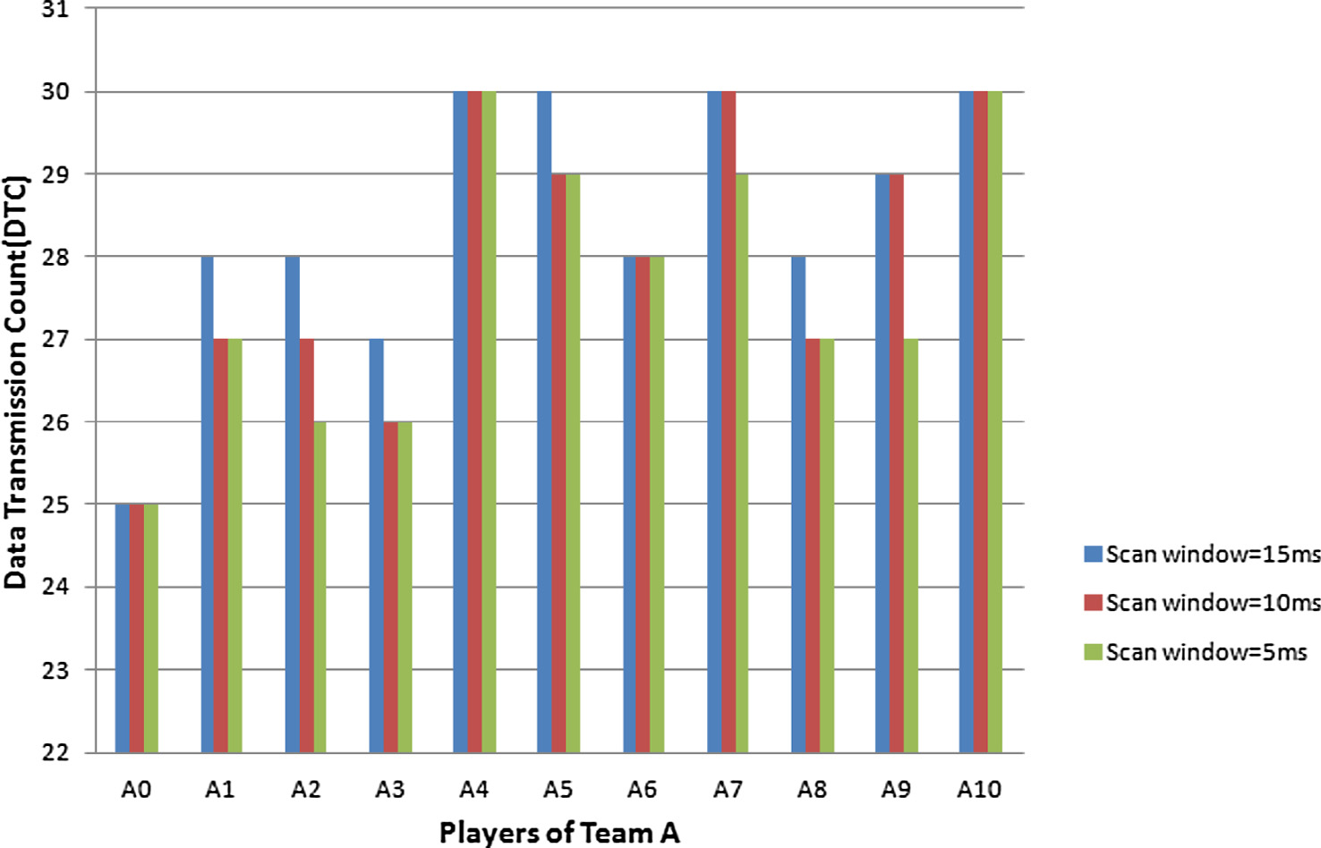

Fig. 36. Data Transmission Count (DTC) by each paler of Team A.

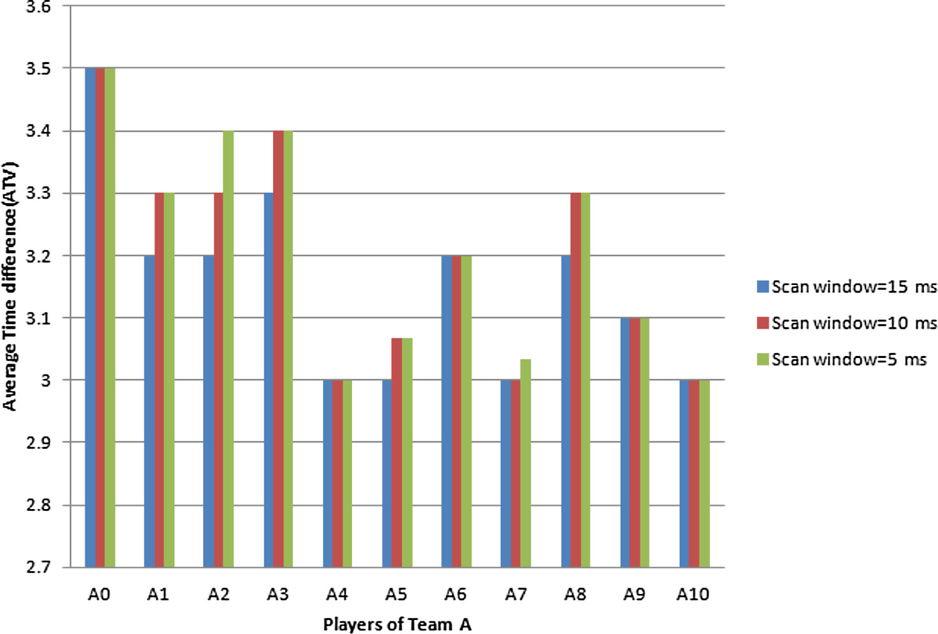

Fig. 37. Average Time Difference (ATV) by each paler of Team A.

model of implementation. Though the nodes are time synchro- nised, still there are some misses of data packet occur due to the three advertisements do not fall within scan window limit of the masters or the players are far from masters.

1. Conclusion

In this paper we have proposed a new architecture of IoT net- works, where sensor networks and MANET are combined together for efficient communication with the Internet Gateways. We have

considered two different applications of IoT network with different MAC layer protocols at the sensor nodes. For coexistence of differ- ent technology used by different type of nodes, we have proposed some frequency allocation scheme among these nodes. And finally we have shown the performance of the network and feasibility of our implementation by simulating our proposed IoT network mod- els for different applications. Security is one of the important issues in IoT, which is not taken care in the proposed model except UUID in soccer model. Thus future work will be incorporating security issues in our present work.

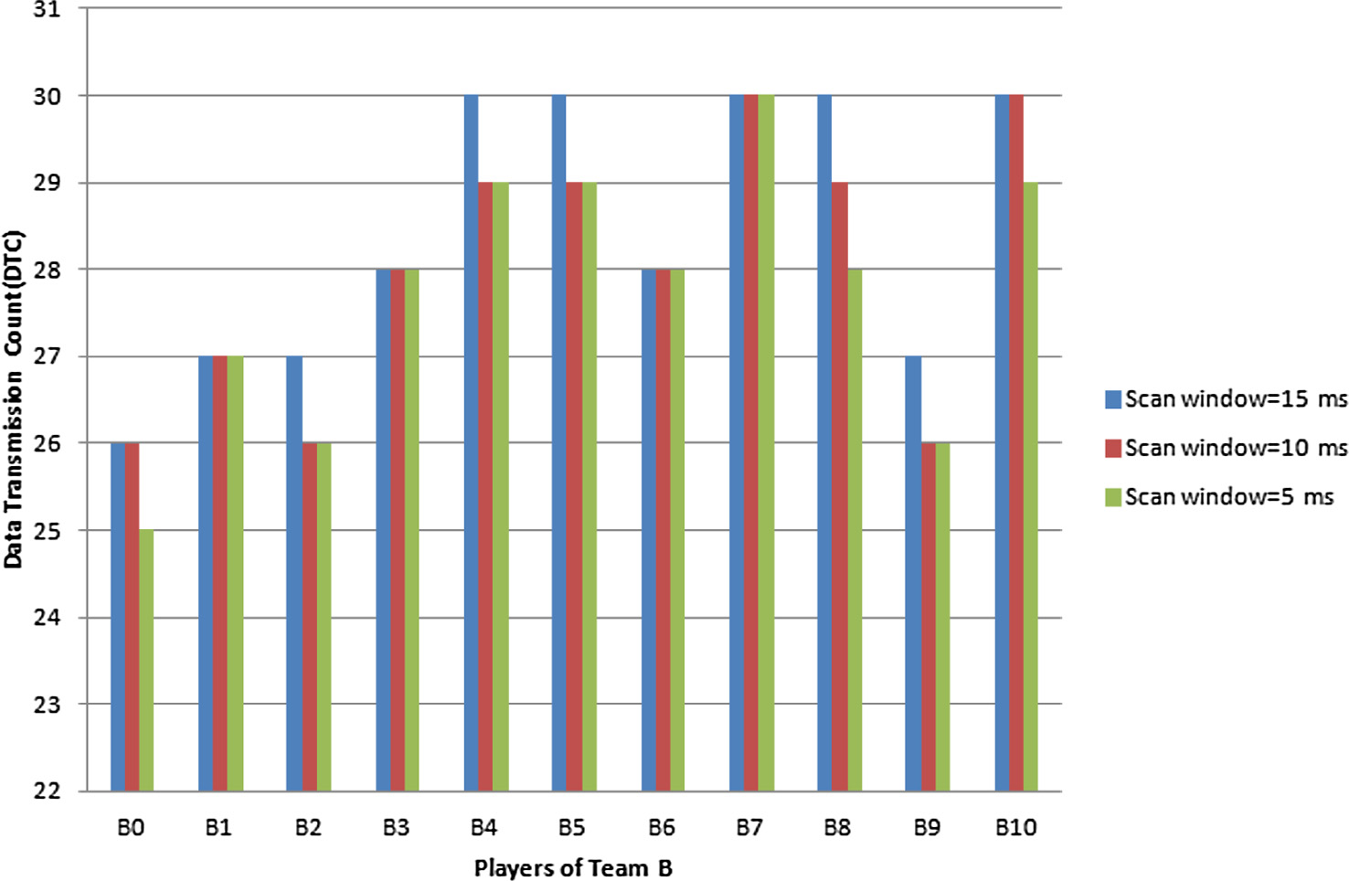

Fig. 38. Data Transmission Count (DTC) by each paler of Team B.

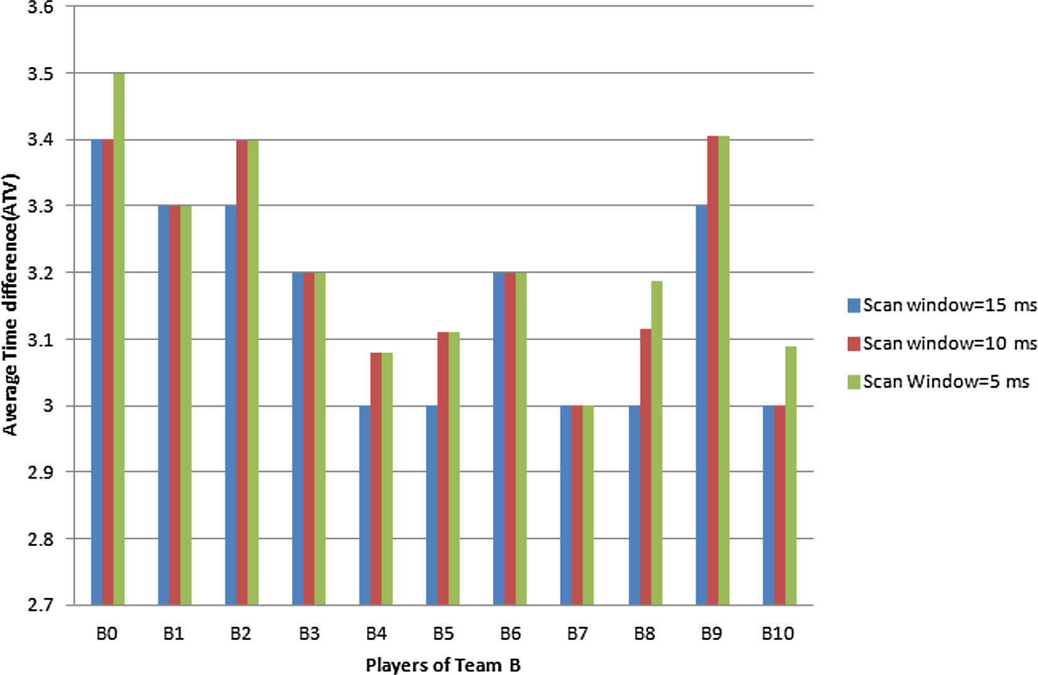

Fig. 39. Average Time difference (ATV) by each paler of Team B.

References

1. [Al-Ali AR, Zualkernan Imran, Aloul Fadi. A mobile gprs-sensors array for air](http://refhub.elsevier.com/S1110-8665(17)30109-3/h0005) [pollution monitoring. IEEE Sens J 2010;10(10):1666–71](http://refhub.elsevier.com/S1110-8665(17)30109-3/h0005).
2. Arora Anish, Ramnath Rajiv, Ertin Emre, Sinha Prasun, Bapat Sandip, Naik Vinayak, et al. Exscal: Elements of an extreme scale wireless sensor network. In: 11th IEEE international conference on embedded and Real-Time Computing Systems and Applications (RTCSA’05). IEEE; 2005. p. 102–8.
3. [Atzori Luigi, Iera Antonio, Morabito Giacomo. The internet of things: a survey.](http://refhub.elsevier.com/S1110-8665(17)30109-3/h0015) [Comput Netw 2010;54(15):2787–805](http://refhub.elsevier.com/S1110-8665(17)30109-3/h0015).
4. Batra Anuj, Ho Jin-Meng, Anim-Appiah Kofi. Proposal for intelligent bt frequency hopping for enhanced coexistence. Texas Instrument. IEEE; 2001.

p. 802–15.

1. [Bellavista Paolo, Cardone Giuseppe, Corradi Antonio, Foschini Luca.](http://refhub.elsevier.com/S1110-8665(17)30109-3/h0025) [Convergence of MANET and WSN in IoT urban scenarios. IEEE Sens J 2013;13](http://refhub.elsevier.com/S1110-8665(17)30109-3/h0025) [(10):3558–67](http://refhub.elsevier.com/S1110-8665(17)30109-3/h0025).
2. [Chakrabarti Arnab, Sabharwal Ashutosh, Aazhang Behnaam. Using predictable](http://refhub.elsevier.com/S1110-8665(17)30109-3/h0030) [observer mobility for power efficient design of sensor networks. In:](http://refhub.elsevier.com/S1110-8665(17)30109-3/h0030) [Information processing in sensor networks. Springer; 2003. p. 129–45](http://refhub.elsevier.com/S1110-8665(17)30109-3/h0030).
3. LAN/MAN Standards Committee, et al. Part 15.4: wireless medium access control (mac) and physical layer (phy) specifications for low-rate wireless personal area networks (lr-wpans). IEEE Computer Society; 2003.
4. Gould Stephanie Corriero David, Haisma Hidde. Can-wearable-tech-beat- sport-doping [<https://www.theguardian.com/sport/2016/jan/11/can-](https://www.theguardian.com/sport/2016/jan/11/can-wearable-tech-beat-sport-doping/) [wearable-tech-beat-sport-doping/>](https://www.theguardian.com/sport/2016/jan/11/can-wearable-tech-beat-sport-doping/) [January 2016].
5. Dohler Mischa, Vilajosana Ignasi, Vilajosana Xavi, LLosa Jordi. Smart cities: an action plan. In: Proc. Barcelona smart cities congress, Barcelona, Spain, 2011. p. 1–6.
6. Dunkels Adam, et al. Efficient application integration in ip-based sensor networks. In: Proceedings of the first ACM workshop on embedded sensing systems for energy-efficiency in buildings. ACM, 2009. p. 43–8.
7. Dunkels Adam, Vasseur Jean-Philippe. Ip for smart objects, Ipso alliance white paper 1; 2008.
8. Hernández-Mu noz José M, Vercher Jesús Bernat, Mu noz Luis, Galache José A, Presser Mirko, Hernández Gómez Luis A, et al. Smart cities at the forefront of the future internet. In: The future internet assembly. Springer; 2011. p. 447– 62.
9. Howitt Ivan, Gutierrez Jore A. IEEE 802.15. 4 low rate-wireless personal area network coexistence issues. In: Wireless communications and networking, 2003. WCNC 2003. 2003 IEEE, vol. 3. IEEE; 2003. p. 1481–6.
10. Hui Jonathan W, Culler David E. Ip is dead, long live ip for wireless sensor networks. In: Proceedings of the 6th ACM conference on embedded network sensor systems. ACM, 2008. p. 15–28.
11. [Jun Zhang, Simplot-Ryl D, Bisdikian C, Mouftah HT. The internet of things. IEEE](http://refhub.elsevier.com/S1110-8665(17)30109-3/h0075) [Commun Mag 2011;49(11):30–1](http://refhub.elsevier.com/S1110-8665(17)30109-3/h0075).
12. Kim E, Kaspar D, Gomez C, Bormann Carsten. Problem statement and requirements for ipv6 over low-power wireless personal area network (6lowpan) routing, Technical report; 2012.
13. Kushalnagar Nandakishore, Montenegro Gabriel, Schumacher Christian. Ipv6 over low-power wireless personal area networks (6lowpans): overview, assumptions, problem statement, and goals, Technical report; 2007.
14. Lee Sangwon, Yoon Dukhee, Ghosh Amitabha. Intelligent parking lot application using wireless sensor networks. In: International symposium on collaborative technologies and systems, 2008. CTS 2008. IEEE; 2008. p. 48–57.
15. [Li Xu, Shu Wei, Li Minglu, Huang Hong-Yu, Luo Pei-En, Wu Min-You.](http://refhub.elsevier.com/S1110-8665(17)30109-3/h0095) [Performance evaluation of vehicle-based mobile sensor networks for traffic](http://refhub.elsevier.com/S1110-8665(17)30109-3/h0095) [monitoring. IEEE Trans Veh Technol. 2009;58(4):1647–53](http://refhub.elsevier.com/S1110-8665(17)30109-3/h0095).
16. Liang Jie. Proposal for collaborative bt and 802.11 b mac mechanisms for enhanced coexistence; 2001. Retreieved form: [<www.ieee802.org/15/pub/](http://www.ieee802.org/15/pub/TG2-Coexistence-Mechanisms.html) [TG2-Coexistence-Mechanisms.html>](http://www.ieee802.org/15/pub/TG2-Coexistence-Mechanisms.html).
17. [Lynch Jerome P, Loh Kenneth J. A summary review of wireless sensors and](http://refhub.elsevier.com/S1110-8665(17)30109-3/h0105) [sensor networks for structural health monitoring. Shock Vib. Digest 2006;38](http://refhub.elsevier.com/S1110-8665(17)30109-3/h0105) [(2):91–130](http://refhub.elsevier.com/S1110-8665(17)30109-3/h0105).
18. [Ma Jian, Chen Canfeng, Salomaa Jyri P. mwsn for large scale mobile sensing. J](http://refhub.elsevier.com/S1110-8665(17)30109-3/h0110) [Signal Process Syst 2008;51(2):195–206](http://refhub.elsevier.com/S1110-8665(17)30109-3/h0110).
19. Maisonneuve Nicolas, Stevens Matthias, Niessen Maria E, Hanappe Peter, Steels Luc. Citizen noise pollution monitoring. In: Proceedings of the 10th annual international conference on digital government research: social networks: making connections between citizens, data and government. Digital Government Society of North America; 2009. p. 96–103.
20. [Minunni Maria, Scarano Simona, Mascini Marco. Affinity-based biosensors as](http://refhub.elsevier.com/S1110-8665(17)30109-3/h0120) [promising tools for gene doping detection. Trends Biotechnol 2008;26](http://refhub.elsevier.com/S1110-8665(17)30109-3/h0120) [(5):236–43](http://refhub.elsevier.com/S1110-8665(17)30109-3/h0120).
21. [Mulligan Catherine EA, Olsson Magnus. Architectural implications of smart](http://refhub.elsevier.com/S1110-8665(17)30109-3/h0125) [city business models: an evolutionary perspective. IEEE Commun Mag](http://refhub.elsevier.com/S1110-8665(17)30109-3/h0125) [2013;51(6):80–5](http://refhub.elsevier.com/S1110-8665(17)30109-3/h0125).
22. Munir Saad Ahmed, Ren Biao, Jiao Weiwei, Wang Bin, Xie Dongliang, Ma Jian. Mobile wireless sensor network: architecture and enabling technologies for ubiquitous computing. In: 21st International conference on advanced

information networking and applications workshops, 2007, AINAW’07. vol.

2. IEEE; 2007. p. 113–20.

1. [Nuortio Teemu, Kytöjoki Jari, Niska Harri, Bräysy Olli. Improved route planning](http://refhub.elsevier.com/S1110-8665(17)30109-3/h0135) [and scheduling of waste collection and transport. Expert Syst. Appl. 2006;30](http://refhub.elsevier.com/S1110-8665(17)30109-3/h0135) [(2):223–32](http://refhub.elsevier.com/S1110-8665(17)30109-3/h0135).
2. Peintner Daniel, Kosch Harald, Heuer Jorg. Efficient XML interchange for rich internet applications. In: 2009 IEEE international conference on multimedia and expo. IEEE; 2009. p. 149–52.
3. Priyantha Nissanka B, Kansal Aman, Goraczko Michel, Zhao Feng. Tiny web services: design and implementation of interoperable and evolvable sensor networks. In: Proceedings of the 6th ACM conference on Embedded network sensor systems. ACM; 2008. p. 253–66.
4. Sarwar Usman, Sinniah Gopinath Rao, Suryady Zeldi, Khosdilniat Reza. Architecture for 6lowpan mobile communicator system. In: Proceedings of the international multiconference of engineers and computer scientists, vol. 2; 2010.
5. Schaffers Hans, Komninos Nicos, Pallot Marc, Trousse Brigitte, Nilsson Michael, Oliveira Alvaro. Smart cities and the future internet: towards cooperation frameworks for open innovation. In: The future internet assembly. Springer; 2011. p. 431–46.
6. Schneider John, Kamiya Takuki, Peintner Daniel, Kyusakov Rumen. Efficient XML interchange (exi) format 1.0, W3C Proposed Recommendation, 20; 2011.
7. Schor Lars, Sommer Philipp, Wattenhofer Roger. Towards a zero-configuration wireless sensor network architecture for smart buildings. In: Proceedings of the first ACM workshop on embedded sensing systems for energy-efficiency in buildings. ACM; 2009. p. 31–6.
8. Zach Shelby. Constrained RESTful Environments (CoRE) Link Format, RFC 6690, October 2015.
9. Shelby Zach, Frank Brian, Sturek Don. Constrained application protocol (coap), Internet-Draft draft-ietf-core-coap-02, IETF Secretariat, September 2010

[<http://www.ietf.org/internet-drafts/draft-ietf-core-coap-02.txt>](http://www.ietf.org/internet-drafts/draft-ietf-core-coap-02.txt).

1. Sikora Axel, Groza Voicu F. Coexistence of ieee802. 15.4 with other systems in the 2.4 ghz-ism-band. In: 2005 IEEE instrumentation and measurement technology conference proceedings, vol. 3. IEEE; 2005. p. 1786–91.
2. [Vilajosana Ignasi, Llosa Jordi, Martinez Borja, Domingo-Prieto Marc, Angles](http://refhub.elsevier.com/S1110-8665(17)30109-3/h0185) [Albert, Vilajosana Xavier. Bootstrapping smart cities through a self-sustainable](http://refhub.elsevier.com/S1110-8665(17)30109-3/h0185) [model based on big data flows. IEEE Commun Mag 2013;51(6):128–34](http://refhub.elsevier.com/S1110-8665(17)30109-3/h0185).
3. [Walravens Nils, Ballon Pieter. Platform business models for smart cities: from](http://refhub.elsevier.com/S1110-8665(17)30109-3/h0190) [control and value to governance and public value. IEEE Commun Mag 2013;51](http://refhub.elsevier.com/S1110-8665(17)30109-3/h0190) [(6):72–9](http://refhub.elsevier.com/S1110-8665(17)30109-3/h0190).
4. Wan Chieh-Yih, Eisenman Shane B, Campbell Andrew T, Crowcroft Jon. Siphon: overload traffic management using multi-radio virtual sinks in sensor networks. In: Proceedings of the 3rd international conference on Embedded networked sensor systems. ACM; 2005. p. 116–29.
5. Wang Wei, Srinivasan Vikram, Chua Kee-Chaing. Using mobile relays to prolong the lifetime of wireless sensor networks. In: Proceedings of the 11th annual international conference on Mobile computing and networking. ACM; 2005, p. 270–83.
6. Yarvis M, Kushalnagar N, Singh H, Rangarajan A, Liu Y, Singh S. Exploiting heterogeneity in sensor networks. In: Proceedings IEEE 24th annual joint conference of the ieee computer and communications societies, vol. 2, March 2005, p. 878–90.